**Annex IV**

**De minimis request for gadoids (cod, haddock, whiting) for vessels using bottom trawls (OTB, OTT) >80mm in the Celtic Sea and the Channel (ICES 7b-c, e-k).**

The request for an exemption for de minimis is based on article 15.c.i), due to difficulties to further increase selectivity in this mixed fishery, and on article 15.c.ii), due to disproportionate costs a total application of the landing obligation would cause in this fishery. The fleet is particularly vulnerable for the risk of commercial catch losses an improvement in selectivity would cause.

**Summary**

Motive 3

Definition of the species and the stock 4

Definition of the management unit 4

Characteristics of the fishery and its activity 4

Composition of catches, landings and discards 4

Specifying de minimis volume 6

Discard volume 6

Safeguards 7

References 8

Annexes 9

Annex 1: REJEMCELEC project 9

Annex 2: Catch, landing and discard of TR1 and TR2 fleet in Celtic sea and Western channel 10

Annex 3: Specifying de minimis for 2019 11

Annex 4. Template for the provision of information that defines the fisheries to which de minimis exemptions should apply (template 4.1a from the EWG-16-06 report to the STECF) 12

**Motive**

Vessels having a mixed activity catch simultaneously a diversity of species during the same fishing operation. They are depending financially on several species (whiting, haddock, cod, anglerfishes, megrims, cephalopods), which are often spatially and temporally related. Thus, even if preliminary results of selectivity programs are encouraging (CELCELCT, Catchpole et al.), it is very difficult to improve selectivity without causing significant commercial losses.

This difficulty is even truer regarding the differences of those species morphology. Moreover, even with all scientists’ efforts on developing mixed species models, it is for now unreal to find the appropriate balance between fishing opportunity taking into account technical and biological interactions. That is why, besides the description of choke species issues linked to this activity (mixed fisheries), it is highly necessary to establish suitable solutions.

This specificity of mixed demersal fisheries justifies this exemption request due to this difficulty to improve the selectivity. Several results can attest of commercial catch losses link to selective gear tested until now on mixed gadoids fishery in the Channel (SELECCAB, SELECMER…). For example, the SELECMER program reveals commercial losses between 30% and 36% (pages 49, 54, 59) with the use of different selective devices aiming to reduce cod and small whiting catches (selective grid, eliminator trawl, square mesh, …).

Moreover, there are situations where TAC cannot be entirely consumed without overconsuming the TAC of another stock exploited simultaneously (ICES mixed fisheries advice). This situation is even more exacerbated for fisheries bycatching small stock species, with low productivity and for which TACs are very low and rapidly consumed. It is the case in mixed demersal fisheries.

In addition to those situations of choke species, landing application enforcement may generate disproportionate cost due to hold overloading and increase the sorting time by the crew. Those arguments justify this de minimis request also for disproportionate costs. Several studies demonstrate those aspects: EODE program (Balazuc et al. 2016), discard study Cobrenord (OP Corbenord, 2015), Discard study OPN (Filippi, 2015), Catchpole (Catchpole et al, 2014). In combining those results on trawlers operating in the Channel and the Celtic Sea, we can emphasize that:

* Choke situation with a total landing obligation situation would cause a diminution of approximately 86% of fishing of bottom trawlers in the Channel and the Celtic Sea, with potential fishery closure in March (COBRENORD, 2015).
* The increase of variable costs due to treatment of unwanted catches cause a negative profitability for their exploitation, particularly for small size vessel (<12m) (Catchpole, page 32) ;
* In bottom trawler case in the Channel, total landing obligation enforcement would cause a workable time increase on board of 32% to 68% depending on vessel size (EODE, 2016). Besides, 20% of fishing trip could be concerned by hold overloading issues (EODE, 2016) and cause an increase of travel time of 9% to the detriment of fishing time (COBRENORD, 2015).

This de minimis request aims at giving some flexibility needed for fishermen, exercising bottom trawler metier, to implement the landing obligation.

**This request could be modified depending on needs identified for 2020.**

Regarding the justification below, member states propose the following exemption: “On the basis of scientific evidence and rationale provided in Annex ? the NWW group recommends that by way of derogation from Article 15(1) of Regulation (EU) No 1380/2013, the following quantities may be discarded: for cod, haddock, whiting combined, up to a maximum of 7 % in 2019 and 2020, up to a maximum of 6 % in 2021 and 2022, and up to a maximum of 5% from 2023 of the total annual catches of those species by vessels using bottom trawls of more than 80 mm (OTB, OTT) in ICES divisions 7 b-c, e-k.

**Definition of the species and the stock**

- Haddock 7b-k: ICES advises that when the MSY approach is applied, catches in 2018 should be no more than 8 358 tonnes. . If discard rates do not change from the long-term average, this implies landings of no more than 5911 tonnes. The spawning-stock biomass (SSB) peaked in 2011 as the very strong 2009-year class matured; this was followed by three years of below-average recruitment which led to a rapid decline in SSB after 2011. Recruitment in 2013 was above average and in 2018 above MSY Btrigger. Fishing mortality (F) has been above FMSY for the entire time-series.

- Whiting -7e-k: ICES advises that when the MSY approach is applied, catches in 2018 should be no more than 19 429 tonnes. The SSB shows an increasing trend from 2008 and remains above MSY Btrigger; Fishing mortality declined from 2007 to 2012, then increase but still below FMSY. Recruitment between 2010 and 2012 was below average, whereas the 2013-year class is estimated to be the second highest in the series.

- Cod 7e-k: ICES advises that when the MSY approach is applied, catches in 2018 should be no more than 3428 tonnes. If discard rates do not change from the average of the last 3 years (2014–2016), this implies landings of no more than 3076 tonnes. Recruitment has been highly variable over time with occasional very high recruitment. The 2011 and 2012 year classes are estimated well below the average of the time-series, but the 2013-year class is above average. Spawning-stock biomass (SSB) is close to Blim in 2014 and 2015. Fishing mortality (F) has declined since 2005 and fluctuated in recent years. Fishing mortality remains above FMSY.

**Definition of the management unit**

**Characteristics of the TR 1 fishery and its activity**

The NWW Discard Atlas (Catchpole and Ribeiro Santos, 2014) reports that "the TR1 fishery is the predominant fishery in the Celtic Sea (including 7e, excluding 7d), with the highest fishing effort, accounting for 23% of the total effort (STECF 2013). It has a widespread distribution in the whole area, but most of the effort is exerted in ICES VII e, g and h (Fig 1). The countries that contributed with most effort were France, Spain, Ireland and England. The TR1 fishery is characterized to be a mixed fishery, mainly targeting ‘gadoid’ species, such as haddock (*Melanogrammus aeglefinus*), cod (*Gadus morhua*) and whiting (*Merlangus merlangus*) as well as anglerfishes and megrims. There is an important TR1 mixed fishery in ICES 7j-k, mainly operated by Irish and Spanish vessels and targeting anglerfishes (*Lophius* spp), megrims (*Lepidorhombus whiffiagonis*), hake (*Merluccius merluccius*), haddock and whiting."

The fishing operations occur in depth ranging from 80 to 250 m. They last between 2 and 4 hours. Fishing trips duration depends on the seasons and on the weather forecast, from 4 to 15 days (~13 days in average for French vessels, 4-9 days for Irish vessels).

The French vessels that would be concerned are mainly bottom otter trawlers. In 2016, 132 vessels of more than 18m were having this activity in Celtic Sea and Western channel (Cornou *et al.* 2017).

In 2016, around 127 Irish vessels greater than 12m in length were recorded a using TR1 gear in the Celtic Sea. These vessels either targeted ‘gadoid’ species, such as haddock cod (Gadus morhua) and whiting or more mixed fisheries in ICES VIIj-k, targeting anglerfish, megrim, hake, haddock and whiting.

**Characteristics of the TR2 fishery and its activity**

The trawlers with a codend mesh size range 80-100mm is the fishery with second highest effort in Celtic Sea, accounting for 18% of the total effort. It is less widespread than the TR1, and the main 13 fishing areas are localized in ICES 7e, close to the English and French shores and in 7g, close to the Irish shore. The TR2 fishery in the Celtic Sea is mainly characterized by: 1) fishery for Norway lobster (termed ‘Nephrops’) operated mainly by Irish trawlers. There are significant Nephrops fisheries in the Smalls, Labidie and Porcupine bank that are not shown in the effort maps; 2) mixed fishery targeting anglerfish, gadoid species and non-quota species (cuttlefish and squid), taking place in VIIe close to the English and French shore; 3) Spanish-mixed fishery (otter trawl with codend mesh size 70-99mm) targeting flatfish, principally megrims and anglerfish, with hake as one of the main by-catches. Effort is distributed on shallow waters of Grand Sole and Porcupine Bank fishing mainly in Division 7j. According with the STECF data (2013), most of the TR2 effort is mainly operated by English and French vessels, however most of the Spanish effort in the Celtic Sea are TR2 and is likely to be underestimated due to a lack of data.

Overall 138 Irish vessels were involved in these fisheries in the Celtic Sea in 2016. Of these, 73 vessels targeted *Nephrops*, with the remaining 65 vessels targeting mixed finfish including haddock, whiting, cod, *Nephrops*, megrim, hake and anglerfish. These latter vessels catch a broad range of species and the relative contribution each species makes at an individual vessel level is highly variable. Whiting, haddock and a lesser extent cod are important components of the landings from both of these fleets making up approximately 36% of the total landings by volume of quota species. Most landings come from ICES divisions 7f, g and j.

The French vessels that would be concerned are mainly bottom otter trawlers. In 2016, 152 vessels were having this activity, mainly in the Western channel (Cornou *et al.* 2017).

**Composition of catches, landings and discards – TR1**

When they are targeting gadoids and anglerfishes, bottom trawlers are catching a group of varied species, which several are under TAC management: rays, plaice, horse-mackerel, boarfishes etc. Therefore, those species are potential choke species for those vessels (Fig. 1).

Based on STECF database (2013-2016) we tried to establish a catch and discard profile for those vessels.

It is important to notice that data used are not always representative, thus an extreme care on the interpretation and use of the estimates presented below is needed. The non representativness of discard data in general and the mixed character of this fishery makes hard to establish a profile discard and to estimates which quantity of every species could be discarded under the use of a de minimis as presented here. Nevertheless, it gives us a general idea based on the best data available for now (STECF data). It is also important to notice that discards and catches may highly vary from a year to another.

Based on the estimates, catches of gadoids (whiting, haddock, cod) represent approximately 28.5% of overall catches (based only on TAC species catch) (Fig 1; Annex 2).

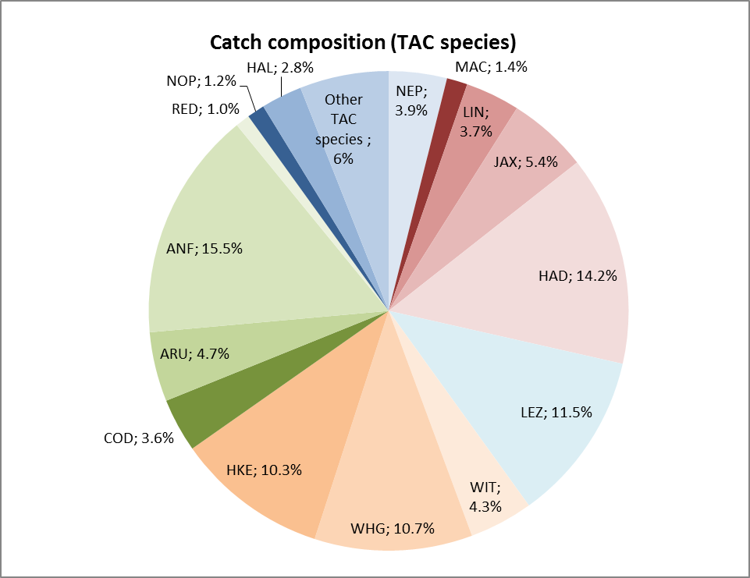

**Figure 1:** catch composition of TAC species in weight for bottom trawlers with a mesh size superior to 100mm in Celtic sea and Western Channel (STECF data base - average 2013-2016)

Discards represent approximately 27% of the total catches (average 2013-2016). This is consistent with French data observer program which indicates an overall discard rate for this fishery of 32% in 2014 (Cornou et al., 2017).

Species discarded are mainly haddock, hake, whiting, megrims (Fig 2). For those species, causes of discards are limited quota, size, or non-market possibility for small size. Other species without commercial value (horse mackerel) are also discarded. According to STECF data, haddock, whiting and cod discards of vessels using TR1 gear in the Celtic Sea and Western Channel represent 38% of the total volume of TAC species discards (Figure 2).

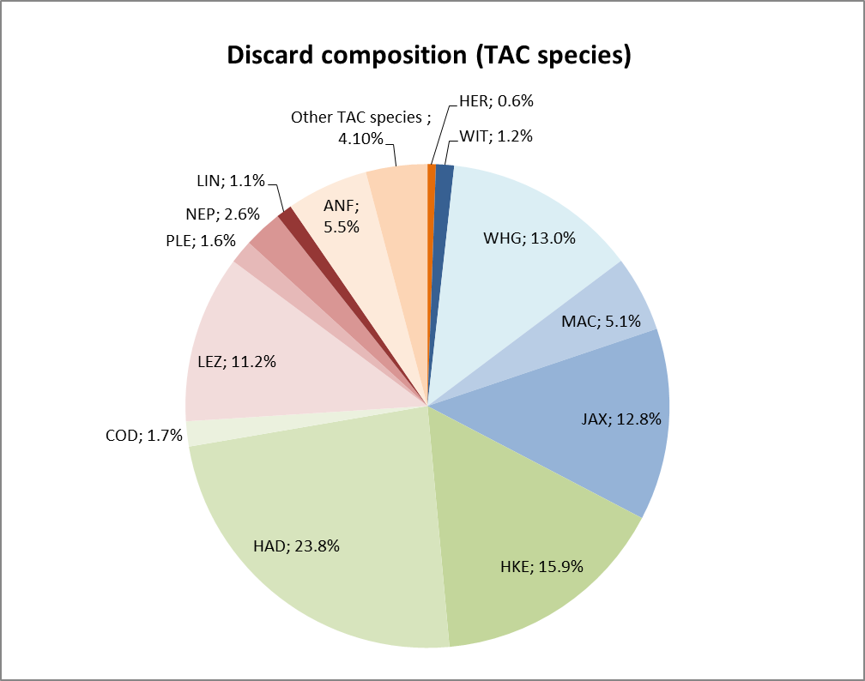

**Figure 2:** Discard composition of TAC species for bottom trawlers with a mesh size superior to 100mm in Celtic sea and Western Channel (STECF data base - average 2013-2016)

**Composition of catches, landings and discards – TR2**

Many of the TR2 vessels target a range of species as shown in Figure 3. Depending on the fleet involved some or all of these are potential choke. For instance for the Irish fleet haddock, cod and sole are the most likely to become choke species for the TR2 fleet. However, other species such as hake, anglerfish, plaice and skates and rays are other potential choke species

Based on STECF database (2013-2016) a catch and discard profile for those vessels has been established for TR2 vessels. The same limitations with the data as described above apply for the TR2 catch data.

Based on the estimates, catches of gadoids (whiting, haddock, cod) represent approximately 20% of overall catches (based only on TAC species catch) (Fig 3; Annex D).

**Figure 3:** catch composition of TAC species in weight for bottom trawlers with a mesh size less than 100mm in Celtic sea and Western Channel (STECF data base - average 2013-2016)

The main species discarded are nephrops, whiting, hake and horse-mackerel (Fig 4). For those species, causes of discards are limited quota, size, or low market value. Other species without commercial value (forkbeard and mackerel) are also discarded. According to STECF data, haddock, whiting and cod discards of vessels using TR2 gear in the Celtic Sea and Western Channel represent 13% of the total volume of TAC species discards (Figure 4).

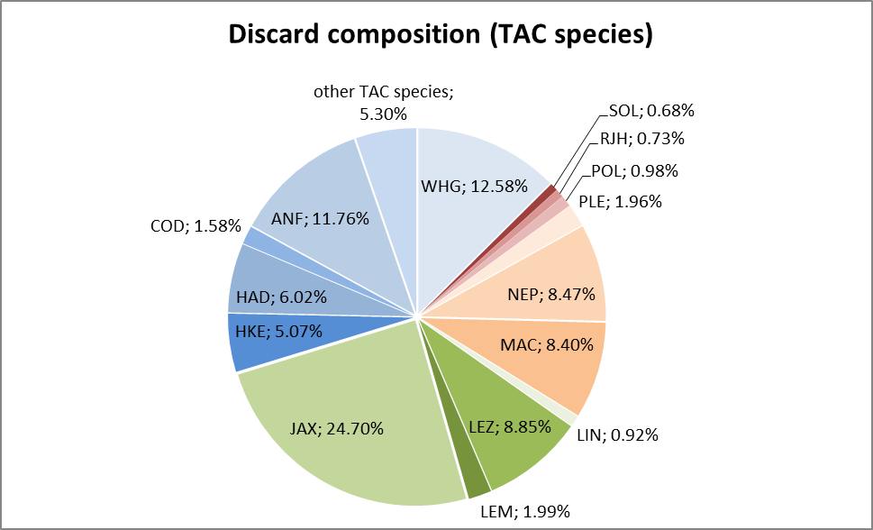

**Figure 4:** Discard composition of TAC species for bottom trawlers with a mesh size less than 100mm in Celtic sea and Western Channel (STECF data base - average 2013-2016)

Additional technical measures were introduced through Commission Implementing Regulation (EU) 2015/741 into the TR2 fishery in 2015. This Regulation sets out specific technical measures for most of ICES divisions 7f, 7g and the part of 7j that lies north of latitude 50° N and east of 11°W. Article 2 requires all vessels fishing in this area to use a square mesh panel of at least 120mm except vessels targeting whiting. Vessels whose catch in any fishing trip in the area east of 8° west of the Celtic Sea comprises at least 55 % whiting can use a square-meshed panel of at least 100 mm. It is too early to assess actual impacts of these technical measures on whiting and associated stocks given they were only introduced in the second half of 2015. Indications from ICES are that discarding of whiting remains high and therefore it is important that the de minimis exemption for TR2 vessels would remain in place to allow vessels time to adapt their practices to the CFP objectives: for example, to allow fishermen consider further gear modifications to improve selectivity (e.g. T90 codends or larger mesh square mesh panels). For example, Ireland is continuing to look at such options (Browne et al., 2016; Cosgrove et al. 2016 and Tyndall et al., 2017). France is also running programs on selectivity (CELSELECT, REJEMCELECT…).

**Specifying de minimis volume**

**Discard volume – TR1**

Based on STECF data (average 2013-2016, see annexe 2), we established a discard profile in order to estimate maximum volumes of species that would be theoretically discarded under a de minimis as presented in this case. All precautions shall be taken in interpreting and using those estimates as discards can vary significantly from a year to another due to the aleatory specify of fishery activity. Moreover, data used are not always representative. Nevertheless, estimates present hereafter can give a general idea of maximum volume discard estimates.

Those data present an average of catch and discard data for 2013, 2014, 2015 and 2016 (STECF data base).

Based on Annex II (STECF data base), mixed demersal vessels in Celtic Sea and Western Channel caught 70432.2 tonnes of TAC species (average 2013-2016) of which **20057.6 tonnes** were whiting, cod and haddock catches. Thus, a de minimis of 7% would represent theoretically a maximum volume of discards of **1404 tonnes** (for all European vessels using TR1 gear in Celtic sea and Western Channel). Over those 1404 tonnes, and according to the profile of discard established on those STECF data, discards of each species would represent (see annex 3):

- Whiting: 33% of the total gadoids discard volume (cod, whiting, and haddock)

- Haddock: 61.5% of the total gadoids discard volume (cod, whiting, and haddock)

- Cod: 5.1% of the total gadoids discard volume (cod, whiting, and haddock)

**Discard Volume – TR2**

Annex III provides equivalent data for TR2 vessels operating in the Celtic Sea. Based on annex E, TR2 mixed demersal vessels in Celtic Sea and Western Channel caught 61378.89 tonnes of TAC species (average 2013-2016) of which **12 383 tonnes** were whiting, cod and haddock catches. Thus, a de minimis of 7% would represent theoretically a maximum volume of discards of **867 tonnes** (for all European vessels using TR2 gear in Celtic sea and Western Channel). Discards of each species would represent (see Annex III):

- Whiting: 53% of the total gadoids discard volume (cod, whiting, and haddock)

- Haddock: 43% of the total gadoids discard volume (cod, whiting, and haddock)

- Cod: 3.64% of the total gadoids discard volume (cod, whiting, and haddock)

**Safeguards**

This de minimis would respond partly in how to implement landing obligation in specific fisheries where it is difficult in a 2019 scenario to implement it. Also this de minimis has its limits and its risks. It is true that the combination of several species can represent a high volume of possible discards. Nevertheless, it will never be more than 7% of the catches concerned.

As said before, volume and composition of catches can be unpredictable and vary from a year to another. It is also important to emphasize that, because of the mixed character of the fisheries it is highly unlikely that only one species would be discarded. This is all the point of a combined de minimis: giving some flexibility needed for fisherman to face the variability of by-catch stocks abundance.

Nevertheless, in order to limit the risk of discarding only one species and because discard rate can be significantly different from a species to another it is propose to put in place safeguard.

Here after is a proposition of safeguards that need to be evaluated and discussed:

According to the discard profile of the fishery (see annex II), a margin of 25% shall apply. This margin would allow the flexibility needed to face the variability of catches and discards. On the overall discard volume permitted by this exemption, only the proportion calculated (+25%) could be discarded on the overall discards. In that case, and taking all precaution in using those data, this would allow fishermen to discard:

For the TR1 fleets this would equate to: (see annexe II)

- Whiting: a maximum of 41.67% of the total gadoids discards volume (cod, whiting, haddock). This 41.67 % represents 585 tonnes over the 1 404 tonnes of discard allowed by a 7% de minimis. If 585 t of whiting is discarded, then, 819 t will remain to cover the discards of haddock and cod.

- Haddock: a maximum of 76.92% of the total gadoids discards volume (cod, whiting, haddock). This 76.92% represents 1 080 tonnes over the 1 404 tonnes of discard allowed by a 7% de minimis. If 1 080 t of haddock is discarded, then, 324 t will remain to cover the discards of whiting and cod.

- Cod: a maximum of 6.41% of the total gadoids discards volume (cod, whiting, haddock). This 6.41% represents 90 tonnes over the 1 404 tonnes of discard allowed by a 7% de minimis. If 90 t of cod is discarded, then, 1 314 t will remain to cover the discards of whiting and haddock.

For the TR2 fleets this would equate to: (see annexe III)

- Whiting: a maximum of 66% of the total gadoids discards volume (cod, whiting, haddock). This 66% represents 460 tonnes over the 867 tonnes of discard allowed by a 7% de minimis. If 460 t of whiting is discarded, then, 407 t will remain to cover the discards of haddock and cod.

- Haddock: a maximum of 54.1% of the total gadoids discards volume (cod, whiting, haddock). This 54.1% represents 375 tonnes over the 867 tonnes of discard allowed by a 7% de minimis. If 375 t of haddock is discarded, then, 492 t will remain to cover the discards of whiting and cod.

- Cod: a maximum of 4.5% of the total gadoids discards volume (cod, whiting, haddock). This 4.5% represents 31.6 tonnes over the 867 tonnes of discard allowed by a 7% de minimis. If 31.6 t of cod is discarded, then, 835.4 t will remain to cover the discards of whiting and haddock.

**Those safeguards should be revised if necessary and according to discard profile that can evolve over the years.**

Only for informative purpose, theoretical volumes of discards are presented in Annex 3.

**Impact on top up calculation**

In light of the impact of discards under de minimis on the size of fishing opportunities there is a need to clearly identify the part of the fleet taking advantage of a de minimis exemption and the discards it accounts for, in particular in the case of combined de minimis exemptions.

Recording of gear codes would facilitate the registration of overall catch volumes as well as the volume of discards of the various species concerned.

Furthermore, for combined de minimis exemptions, as in this case, the quantity representing the x[7-6-5]% needs to be divided among the exempted species as shown in the last column of Annex IIb & IIIb [cf. infra]; column representing the respective maximum estimated discards volumes (per stock) in the fishery (TR1 or TR2) concerned, +25% safeguard included. Such volumes are the ones to be deducted from the quota uplift for each stock, in order to express the fishing opportunities in ‘real TAC’ (and not TA-C understood as TA-Landings).

**References**

Balazuc A., Goffier E., Soulet E., Rochet M.J., Leleu K., 2016. EODE – Expérimentation de l’Obligation de DEbarquement à bord de chalutiers de fond artisans de Manche Est et mer du Nord, et essais de valorisation des captures non désirées sous quotas comm

unautaires, 136 + 53 pp.

Browne, D., Cosgrove, R., and Tyndall, P. 2016. Assessment of T90 mesh in a fishery targeting whiting in the Celtic Sea. BIM Report, June 2016.

Catchpole T, Elliot S., Peach D., Mangi S., 2014. Final report: The English discard ban trial. Cefas. Departement for environment food and rural affairs. 65p. <https://www.gov.uk/government/uploads/system/uploads/attachment_data/file/361564/Discard_Ban_Trial_Report_v11.pdf>

Cefas (2014). Discard Atlas of the North Western Waters Demersal Fisheries. <http://archimer.ifremer.fr/doc/00287/39819/>

Cornou Anne-Sophie, Dimet Joel, Tetard Alain, Gaudou Olivier, Quinio-Scavinner Marion, Fauconnet Laurence, Dube Benoit, Rochet Marie-Joelle (2014). Observations à bord des navires de pêche professionnelle. Bilan de l'échantillonnage 2013.

Cornou Anne-Sophie, Quinio-Scavinner Marion, Delaunay Damien, Dimeet Joel, Goascoz Nicolas, Dube Benoit, Fauconnet Laurence Rochet Marie-Joelle (2015). Observations à bord des navires de pêche professionnelle. Bilan de l'échantillonnage 2014. <http://archimer.ifremer.fr/doc/00286/39722/38188.pdf>

Cornou Anne-Sophie, Quinio-Scavinner Marion, Delaunay Damien, Dimeet Joel, Goascoz Nicolas, Dube Benoit, Fauconnet Laurence Rochet Marie-Joelle (2016). Observations à bord des navires de pêche professionnelle. Bilan de l'échantillonnage 2015. <http://archimer.ifremer.fr/doc/00353/46441/46185.pdf>

Cornou Anne-Sophie, Quinio-Scavinner Marion, Delaunay Damien, Dimeet Joel, Goascoz Nicolas, Dube Benoit, Fauconnet Laurence Rochet Marie-Joelle (2017). Observations à bord des navires de pêche professionnelle. Bilan de l'échantillonnage 2016.

Cosgrove, R., Browne, D., Tyndall, P., McHugh, M., Oliver, M., Minto, C., Burke, B., Montgomerie, M. 2016. Assessment of a dual codend with net separator panel in an Irish Nephrops fishery. Fisheries Conservation Report, December 2016.

Filippi, 2015. Etude Rejet : Obligation de débarquement des captures indésirées : Etude de l’impact de la règlementation sur la filière pêche bas-normande à partir de données collectées en mer. 71p.

ICES. 2016c. Mixed-fisheries advice for divisions 7.b-c and 7.e-k (Celtic Sea). In Report of the ICES Advisory Committee, 2016. ICES Advice 2016, Book 5, section 5.2.7.2. <http://www.ices.dk/sites/pub/Publication%20Reports/Advice/2015/2015/mix-celt.pdf>

OP COBRENORD, 2015. Obligation de Débarquement au sein de l’Organisation de Producteurs COBRENORD : Evaluation des rejets de la flottille hauturière et analyse d’impacts. 50p.

Tyndall, P., Oliver, M., Browne, D., McHugh, M., Minto, C., Cosgrove, R. 2017. The SELTRA sorting box: A highly selective gear for fish in the Irish Nephrops fishery. Fisheries Conservation Report. February 2017.

Vogel Camille (2016). Rapport bibliographique « Sélectivité des engins de pêche ». <http://archimer.ifremer.fr/doc/00317/42869/42327.pdf>

**Additional information**

**ANNEX I - REJEMCELEC project**

**REJEMCELEC : Project presentation**

**Projet REJEMCELEC :**

*Réduction des rEJEts en Manche et mer Celtique par la sELECtivité des engins de pêche (Discards reduction in Western Channel and Celtic sea by increasing gear selectivity)*



**RESUME**

In order to mitigate the negative impacts landing obligation will have on their fisheries, the PO COBRENORD and OPBN set up the REJEMCELEC project. The main goal is to find combinations of selective devices that suit the selectivity issues identified in their trawler fisheries. This need comes from a lack of selectivity studies on those fisheries, especially bottom trawl targeting gadoids in western channel and semi-pelagic trawl targeting mackerel.

To achieve this objective, the following methodology will be used:

1. Identify the selectivity issues to address with quantitative data and qualitative interview with fishermen. A problem to solve could be to let escape little gadoids and to keep squid in VIIf area during autumn;
2. For each case, define and construct a customized selective device ;
3. Compare the selective trawl with a normal trawl by collecting data during at-sea trials;
4. Assess each device according to three criteria: unwanted catch escapement, commercial losses and, in a qualitative way, the practical aspect of the new gear.

Devices will be based on existing technology such as T90, square mesh panel, etc. Nerveless, some innovations could be tested :

* Use of red net pieces for selective devices. Some studies show that red color may not be seen by fish and so they would try to escape in priority by this “opening”;
* Use of T90 only in the extension rather than in the cod end in order to keep squid. In fact, it seems that squid has a straight escapement behavior and goes quickly to the cod end;
* Eight faces extension and cod end to improve filtration and guide squids to the cod end. Based on fish behavior assumptions, we are expecting the unwanted fish to escape through a selective device put on the back of the extension (ex: square meshes).

The study results will be communicated through information letters and two meetings with partners and media.

**Starting date**

01/12/2015

**Duration**

2 years

**Pour plus d'info :** [**http://www.cobrenord.com/2016/12/06/projet-rejemcelec-avancee-et-travaux-en-cours/**](http://www.cobrenord.com/2016/12/06/projet-rejemcelec-avancee-et-travaux-en-cours/)

**ANNEX II - a) Catch, landing and discard of TR1 fleet in Celtic sea and Western channel**



**ANNEX II - b) Specifying de minimis for 2019 of TR1 fleet in the Celtic Sea**



Vessels belonging to a fishery have overall the same activity over the years, therefore, the discard's volume of this fishery can vary a little from one year to another. On the other hand, because of the mixed character of the fisheries, it is possible that the average discard composition slightly vary. It can be estimated that the discard share of a species can range from 25% around the average. Hence, a safeguard of 25% shall apply [green box].

Also, it has to be said that, if for one species included in the de minimis, its discard share is raised by 25%, then the discard share of the two other species will be reduce, the sum must be equal to 100%.

For example, if whiting, instead of representing 33% of the discard share, represents 41.67% (increase of the average by 25%), then the total discard shares of cod and haddock combined will have to be of 100-41.67 = 58.33%, and cod will represent less than 5.1% of the overall discard or/and haddock less than 61.5% (see the blue column: estimated discard share composition).

The values recorded in the column named "maximum discard share" represent the maximum share a species can stand for in the discard composition: but all of them cannot be reach at the same time.

**ANNEX III - a) Catch, landing and discards of TR2 fleet in the Celtic Sea**

Celtic sea (ICES divisions 7b,c,e,f,g,h,j,k) demersal fisheries: landings and discards per species and year for TR2 fleet

**ANNEX III - b) Specifying de minimis for 2019 of TR2 fleet in the Celtic Sea**



Vessels belonging to a fishery have overall the same activity over the years, therefore, the discard's volume of this fishery can vary a little from one year to another. On the other hand, because of the mixed character of the fisheries, it is possible that the average discard composition slightly vary. It can be estimated that the discard share of a species can range from 25% around the average. Hence, a safeguard of 25% shall apply [green box].

Also, it has to be said that, if for one species included in the de minimis, its discard share is raised by 25%, then the discard share of the two other species will be reduce, the sum must be equal to 100%.

For example, if whiting, instead of representing 53% of the discard share, represents 66.31% (increase of the average by 25%), then the total discard shares of cod and haddock combined will have to be of 100-66.31 = 33.69%, and cod will represent less than 3.64% of the overall discard or/and haddock less than 43.31% (see the blue column: estimated discard share composition).

The values recorded in the column named "maximum discard share" represent the maximum share a species can stand for in the discard composition: but all of them cannot be reach at the same time.

**ANNEX IV - Template for the provision of information that defines the fisheries to which de minimis exemptions should apply (template 4.1a from the EWG-16-06 report to the STECF)**

*(This document has been modified for the purpose of this de minimis request)*

|  |  |  |  |  |  |  |  |  |
| --- | --- | --- | --- | --- | --- | --- | --- | --- |
| **Country** | **Exemption applied for (species, area, gear type)** | **Species as bycatch or target** | **Number of vessels subject to LO** | **Estimated landings - gadoids (in tonnes) - 2016** | **Estimated discards - gadoids (in tonnes)** | **Estimated catch - gadoids (in tonnes)** | **Discard rate** | **Estimated de minimis maximum volume (in tonnes) - 5% exemption** |
| EU (mixed fishery) | species: whiting, haddock and cod  area: VII  gear types: TR1 | target and by-catch | FR = 132  IE = 127 | 14414.74 | 8710.98 | 23125.73 | 27% | 1002.88 |
| EU (mixed fishery) | species: whiting, haddock and cod  area: VII  gear types: TR2 | Target and bycatch | IE = 188  FR = 152 | 9097.84 | 9097.84 | 14293.80 | 53% | 619.16 |

Source: STECF data base (annex II and III)

**ANNEX V – Supporting information from Ireland on relevant selectivity trials**

**Description of the Irish Fisheries**

Otter trawlers with codend mesh size over 100mm (TR1) are the predominant fishing gear used in the Celtic Sea, with the highest fishing effort. TR1 gears account for 24% of the total effort (STECF 2017). TR1 fisheries are widespread across the whole area, but most effort is exerted in ICES VII e, f, g and h. The countries that contributed most effort are France, Spain, Ireland and England.

The TR1 fishery is characterized as a mixed fishery, mainly targeting ‘gadoid’ species, such as haddock (*Melanogrammus aeglefinus*), cod (*Gadus morhua*) and whiting (*Merlangus merlangus*) as well as anglerfish and megrim. There is an important TR1 mixed fishery in ICES VIIj-k, mainly operated by Irish and Spanish vessels and targeting anglerfish (*Lophius* spp), megrim (*Lepidorhombus whiffiagonis*), hake (*Merluccius merluccius*) with a bycatch of haddock and whiting.

Otter trawlers using a codend mesh size range between 70-100mm (TR2) have the second highest recorded effort in Celtic Sea, accounting for 22% of the total effort. According to STECF data (2017), TR2 effort is spread amongst Irish, French, Spanish and UK vessels.

The TR2 fishery in the Celtic Sea is widespread and can be characterized by:

* Fisheries for *Nephrops* operated mainly by Irish trawlers in the Smalls, Labadie and Porcupine bank with a bycatch of mainly haddock, whiting and hake;
* A mixed fishery (otter trawl with codend mesh size 70-99mm) targeting megrim and anglerfish, with hake as the main by-catch. Haddock are also caught as a bycatch in this fishery Effort is distributed on shallow waters of Grand Sole and Porcupine Bank fishing mainly in Division VIIj. This fishery involves vessels from Irelnad, France, Spain and the UK; and
* A targeted trawl and seine fishery for whiting with a bycatch of haddock and hake by Irish vessels principally in VIIg.

Fisheries in the Western and Eastern Channel (VIId,e) are not covered by this de minimis as the fisheries in this area are quite different to the fisheries in the Celtic Sea in terms of catch composition and fleets involved. A range of species including anglerfish, gadoid species and non-quota species such as cuttlefish, red mullet and squid are targeted, with the fisheries taking place in VIId and VIIe close to the English and French coasts. Many of the demersal fisheries in VIId are an extension of the fisheries in the southern North Sea to all intents and purposes.

**Supporting Selectivity Trials**

**TR 1**

In the TR1 fisheries improvements in selectivity for haddock and whiting can be achieved through simple increases in codend mesh size, large mesh square mesh panels and the use of T90 or square mesh codends.

Since 2010 six studies have been carried out by Ireland testing the selectivity of a range of gear combinations in the mixed demersal fisheries in the Celtic Sea. These selectivity trials have been carried in both the TR2 fishery targeted mixed demersal species and the TR1 fleet targeting haddock and other gadoids. The trials in the TR1 fishery are relevant as they illustrate the extent of losses in marketable fish that would result if selectivity in these fisheries was increased. Table 3 summarises the trials conducted and the gear combinations tested.

**Table 3 Summary of Celtic Sea selectivity trials carried out by Ireland in the period 2010-2015**

|  |  |  |  |  |  |  |
| --- | --- | --- | --- | --- | --- | --- |
| Date | Vessel | Vessel Type | LOA | KW | Gear combinations tested | Method Used |
| July 20101 | Providence II | OTB Twin-rig | 13m | 112Kw | 100mm  120mm | Paired selectivity |
| July 20101 | Ludovic Geoffray | OTB  Twin-rig | 17m | 308Kw | 100mm+120mm smp  110mm | Paired selectivity |
| Sept 20122 | Foyle Warrior | OTB single-rig | 25m | 600Kw | 100mm + 100mm smp | Covered codend |
| Oct 20133 | Northern Celt | OTB single-rig | 22m | 600Kw | 100mm+ 160mm smp  110mm +100mm smp  120mm + 100mm smp | Covered codend |
| Oct 20144 | Northern Celt | OTB single-rig | 22m | 600Kw | 120mm +120mm smp | Covered codend |
| April 20165 | Foyle Fisher | OTB twin-rig | 24m | 500kw | 80mm T90 | Twin trawl |

1 BIM, 2010; 2 BIM 2012; 3 BIM, 2013; 4 BIM 2014, 5BIM, 2016

**Codend mesh size**

Ireland and other Member States have carried out a number of trials that have measured the effects of increasing mesh size in whitefish fisheries. All of these trials show that increasing mesh size reduces unwanted catches of haddock but also of whiting, megrim, sole, hake and plaice that are commonly caught with haddock.

The first two sets of trials carried out on the Providence II and the Ludovic Geoffray (BIM, 2010) where carried out prior to the technical measures being introduced into the Celtic Sea under Regulation (EU) 737/2012 specifically to protect gadoids. They were carried using the twin trawl method was identified as being applicable for this study as described by ICES (1996). For this method a small mesh codend is attached to one trawl to obtain an estimate of the total fish population entering the test codend, fished on the other side of the twin-rig arrangement. Thus the length-frequency distributions of fish from the two codends allow the calculation of the selectivity parameters of the uncovered test codend. During each haul, the starboard net fished the test configuration and the port net fished a 40 mm diamond mesh control codend to sample the total population on the grounds.

At the time of these trials the legal gear was 80mm codend mesh size (with no square mesh panel). These trials considered the effect of increasing mesh size from 80mm to 120mm in the mixed demersal fishery. Several combinations of codends and square mesh panels were also considered and are reported in the following section. For the TR1 fisheries the results from the trials with codend mesh sizes of 100mm, 110mm and 120mm are relevant.

Table 4 shows the 50% retention length (L50) increases for haddock and for other associated species such as whiting and megrim with increasing mesh size. With a codend mesh size of 100mm the L50 for haddock is below the mcrs, indicating relatively poor selectivity for haddock. The L50 for haddock increases with mesh size and with 110mm and 120mm mesh size L50 is in excess of the mcrs.

**Table 4 50% Retention lengths (L50) and selection ranges (SR) for haddock, whiting and megrim for selected codend mesh sizes**

|  |  |  |  |  |  |  |
| --- | --- | --- | --- | --- | --- | --- |
| Codend mesh size | Haddock (mcrs = 30cm) | | Whiting (mcrs = 27cm) | | Megrim (mcrs = 20cm) | |
| L50 | SR | L50 | SR | L50 | SR |
| 100mm | 281 | 11.91 | 361 | 141 | 34.61 | 111 |
| 110mm | 332 | 19.52 | 37.42 | 182 | 38.52 | 14.72 |
| 120mm | 42.71 | 91 | No data | | 41.21 | 9.51 |

1 Providence II, 2 Ludovic Geoffray

Table 5 shows the percentage of fish below and above mcrs retained in the test codend relative to the total number of fish caught in the test codend and small mesh codend combined i.e.:

Number of fish retained in the test codend

Total number of fish retained in the test codend and small mesh codend (control)

**Table 5 Total numbers of haddock, whiting and megrim retained in the test codends above and below mcrs relative to the total catch**

|  |  |  |  |  |  |  |
| --- | --- | --- | --- | --- | --- | --- |
| Codend mesh size | Haddock (mcrs = 30cm) | | Whiting (mcrs = 27cm) | | Megrim (mcrs = 20cm) | |
| < mcrs | > mcrs | < mcrs | > mcrs | < mcrs | > mcrs |
| 100mm | 66%1 | 53%1 | 99%1 | 67%1 | 100%1 | 68%1 |
| 110mm | 61%2 | 55%2 | 85%2 | 45%2 | 73%2 | 84%2 |
| 120mm | 99%1 | 83%1 | 100%1 | 92%1 | Na1 | 88%1 |

1 Providence II

2 Ludovic Geoffray

These results indicate that as mesh size increases the numbers of haddock below and retained decrease significantly. However, there are also losses of marketable haddock above mcrs mainly in the size range from 30-35cm. For whiting and megrim losses of marketable catch are high with almost no marketable fish retained. It should be noted that these trials were carried out on low horsepowered vessels and therefore represent an extreme case. There are currently very few Irish vessels of this size range currently using this gear type.

**Square Mesh Panels**

The 2010 trials on the Providence II and the Ludovic Geoffray also tested 120mm square mesh panels used in combination with codends of 80mm, 90mm and 100mm (BIM, 2010). All square mesh panels were placed 9-12m from the codend. Relevant to the TR1 fisheries are the trials with the 100m +120mm smp gear combination which is the current legal gear in the Celtic Sea Protection Zone within ICES VIIb-k defined in Regulation (EU) 737/2012. Table 6 below shows the L50s for haddock, whiting, megrim and hake for the range of gears tested.

**Table 6 50% Retention lengths (L50) and selection ranges (SR) for haddock, whiting, megrim and hake for selected codend mesh sizes and smp combinations**

|  |  |  |  |  |  |  |  |  |
| --- | --- | --- | --- | --- | --- | --- | --- | --- |
| Codend/SMPcombination | Haddock (mcrs = 30cm) | | Whiting (mcrs = 27cm) | | Megrim (mcrs = 20cm) | | Hake (mcrs = 27cm) | |
| L50 | SR | L50 | SR | L50 | SR | L50 | SR |
| 100mm/120mm smp1 | 39.2 | 10.8 | No data | | 38.8 | 16.2 | No data | |

1 Ludovic Geoffray,

The results show that the current legal gear (100mm +120mm smp) in the Celtic Sea Protection Zone in section 2 is selective for haddock, with an L50 above the mcrs. Table 7 shows the percentage of fish retained in the test gear combinations relative to the total catch observed from the test gear and the control small mesh codend. The results from these trials show the current 100mm+120mm smp used in the fishery is reasonably selective but still retains relatively high numbers of fish < mcrs but lesser numbers of whiting and megrim < mcrs..

**Table 6 Total numbers of whiting, haddock, megrim and hake retained in the test codends above and below mcrs relative to the total catch**

|  |  |  |  |  |  |  |  |  |
| --- | --- | --- | --- | --- | --- | --- | --- | --- |
| Codend/SMPcombination | Haddock (mcrs= 30cm) | | Whiting (mcrs = 27cm) | | Megrim (mcrs = 20cm) | | Hake (mcrs = 27cm) | |
| < mcrs | > mcrs | < mcrs | > mcrs | < mcrs | > mcrs | < mcrs | > mcrs |
| 100mm/120mm smp1 | 38% | 46% | 12% | 22% | 7% | 31% | 35% | 40% |

1 Ludovic Geoffray

Further trials on the Foyle Warrior in 2012 tested a 100mm codend+ 100mm square mesh panel and an 80mm +110m smp gear combination (BIM, 2012). These trials were conducted using the covered codend method as reported by ICES (1996). The catch in the codend and cover combined provide a measurement of the total fish population entering the codend allowing estimation of selectivity.

Table 8 below shows the L50s for haddock, whiting, megrim and hake for 100mm +100mm gear combinations tested in this trial, which is relevant for the TR1 fisheries. The results show that the 100mm+100mm smp gear combination gives reductions in marketable haddock catches in the range of 30-37cms. Catches of marketable whiting are significantly reduced with these gear combinations in this trial.

**Table 8 50% Retention lengths (L50) and selection ranges (SR) for whiting, haddock and hake for selected codend mesh sizes and smp combinations**

|  |  |  |  |  |  |  |
| --- | --- | --- | --- | --- | --- | --- |
| Codend/SMPcombination | Haddock (mcrs = 30cm) | | Whiting (mcrs = 27cm) | | Hake (mcrs = 27cm) | |
| L50 | SR | L50 | SR | L50 | SR |
| 100mm/100mm smp | 33.4 | 8.2 | 37.4 | 6.5 | 37.9 | 9.6 |

Table 9 below shows the percentage of retained fish at the mcrs and also at different marketable sizes for haddock, whiting and hake above which all fish are routinely retained. Fish between this size and the mcrs are quite often discarded due to their low market value.

**Table 9 Total numbers of haddock, whiting, megrim and hake retained in the test codends relative to the total catch at mcrs and at selected market grades**

|  |  |
| --- | --- |
|  | Percentage Retained |
| 100mm + 100mm smp |
| Haddock at mcrs (30cm) | 26% |
| Grade 3 haddock (37cm) | 70% |
|  |  |
| Whiting at mcrs (27cm) | 25% |
| Grade 3 whiting (32cm) | 14% |
|  |  |
| Hake at mcrs (27cm) | 30% |
| Hake at 1kg (50cm) | 93% |

Three separate sets of trials were carried out on the Northern Celt in 2013 (BIM 2013) and 2014 (BIM, 2014). The first trials were carried out in area VIIj. and anglerfish and megrim were the main target species. The other sets of trials were carried out in VIIg where haddock and whiting were the main target species. These trials looked at a range of gear combinations with codends of 80mm, 100mm, 110mm and 120mm with square mesh panels of 100mm, 120mm, 140mm and 160mm. As with the previous trials the covered codend method was used.

Table 10 shows the L50s for haddock, whiting, megrim and hake for the gear combinations relevant to TR1 fisheries. The L50 for haddock observed with a 120mm + 100mmsmp and 120mm + 120mm smp are thought to be an underestimate. Earlier trials carried out in Area VIa (BIM, 2009) report an L50 of 47.2cm and 38.97cm for haddock with this gear combination. These trials also showed an L50 of whiting of 38.7cm and 33cm for haddock with a 110mm+110m smp.

The L50s for haddock are all above mcrs with the 110mm+100mm smp being the least selective gear combination, In these trials increasing the mesh size square mesh panel appeared to be an effective way of improving selectivity but losses of marketable whiting particularly those just above mcrs were significant.

**Table 10 50% Retention lengths (L50) and selection ranges (SR) for whiting, haddock and megrim for selected codend mesh sizes and smp combinations**

|  |  |  |  |  |  |  |
| --- | --- | --- | --- | --- | --- | --- |
| Codend/SMPcombination | Haddock (mcrs = 30cm) | | Whiting (mcrs = 27cm) | | Megrim (mcrs = 20cm) | |
| L50 | SR | L50 | SR | L50 | SR |
|  | Trial 1 | | | | | |
| 100mm/160mm smp1 | 38.7 | 15 | 52 | 13.5 | 30.5 | 20.5 |
|  | Trial 2 | | | | | |
| 110mm/100mm smp1 | 32.8 | 8.8 | 35.3 | 9.4 | No data | |
| 120mm/100mm smp1 | 38.7 | 15 | 33 | 10.1 | No data | |
|  | Trial 3 | | | | | |
| 120mm +120mm smp2 | 35.4 | 17.5 | 39.3 | 17 | No data | |

1 2013 trials, 2 2014 trial

Table 11 below shows the numbers of fish retained above and below mcrs for each species observed for the different gear combinations.

**Table 11 Total numbers of haddock, whiting and megrim retained in the test codends relative to the total catch at mcrs**

|  |  |  |  |  |
| --- | --- | --- | --- | --- |
|  | Percentage Retained | | | |
| Trial 1 | Trial 2 | | Trial 3 |
| 100mm/160mm smp | 110mm/100mm smp | 120mm/100mm smp | 120mm/120mm smp |
| Haddock < mcrs | 22% | 16% | 6% | 31% |
| Haddock > mcrs | 35% | 30% | 18% | 47% |
|  |  |  |  |  |
| Whiting < mcrs | 8% | 18% | 9% | 7% |
| Whiting > mcrs | 40% | 34% | 45% | 25% |
|  |  |  |  |  |
| Megrim < mcrs | 24% | No data | No data | No data |
| Megrim > mcrs | 37% | No data | No data | No data |

The results show that retention of haddock below mcrs is low with all four gear combinations tested. For haddock above mcrs losses of marketable fish increase with increased mesh size noting that the results from the trials with the 120mm+120mm are thought to be an overestimate due the low numbers of haddock encountered during this trial.

In conclusion as mesh size increase catches of undersized haddock and whiting are reduced. With a mesh size of 120mm unwanted catches below mcrs are reduced to very low levels.

Results from trials in the Celtic Sea in 2013 showed that with a 120mm codend and 100mm square mesh panel virtually no haddock and whiting less than 20cm were retained but there are losses of marketable catch. For haddock these losses are more moderate (~30-50%) and mostly of lower size grade fish. For whiting these losses are much higher (~60-70%).

Trials with large square mesh panels in the Celtic Sea and West of Scotland have shown that increasing the mesh size of the panel over 120mm leads to improvements in selectivity for whiting and haddock. A 2013 Celtic Sea trial of a 100 mm codend with a 160mm SMP yielded reductions in undersize haddock and whiting of 78% and 97% respectively. As with an increase in codend mesh size to 120 mm there were corresponding losses of marketable haddock and whiting.

It is also interesting to note the results from Irish trials in 2015 with T90 codends of 80mm mesh size showed catches of undersized whiting could be reduced by 60% (BIM, 2015). However, in these trials catches of undersize haddock did not decrease. Research conducted by Ifremer in the Celtic Sea has demonstrated that a larger 100 mm T90 mesh substantially reduces catches of undersize haddock but also results in 20 to 30 % losses in market sized whiting.

The results from these trials while not directly comparable given the differences in vessels, gears, the methodologies used to measure selectivity, catch composition and the prevailing environmental conditions which all have a bearing on selectivity do support the justification for this de minimis exemption. The trials show increasing selectivity by whatever means generally results in reductions in undersize haddock and whiting but also leads to losses of marketable haddock and whiting and other species caught in the fishery.

**TR 2**

In the TR2 fisheries the main focus of Irish selectivity work has been in improving selectivity in the directed *Nephrops* fisheries. The trials have considered increasing codend mesh size, square mesh and other types of escape panels as well as the use of rigid sorting grids.

The vessels operating in this fishery in the Celtic Sea have been subject to the Landing Obligation since 2015 for *Nephrops* and whiting. Haddock has not been subject to the Landing Obligation as yet. ICES report that discarding of haddock in the *Nephrops* fisheries in the Celtic Sea can be high despite the introduction of improved selectivity measures. However, discard rates differ between FUs with the highest discard rates reported in the Smalls (FU 22) and Aran grounds (FU 17). Discards of haddock are much lower in the Porcupine (FU 16) and Labadie (FU 20-21) fisheries.

Since 2009, eleven studies have been carried out by Ireland testing the selectivity of a range of gear combinations in directed *Nephrops* fisheries. Much of this work has been carried out in the *Nephrops* fisheries in the Irish Sea but is considered representative of the *Nephrops* fisheries in the Celtic Sea given the gears used and the catch compositions are similar. Table 12 summarises the trials conducted and the gear combinations tested

|  |  |  |  |  |  |  |
| --- | --- | --- | --- | --- | --- | --- |
| Date | Vessel | Vessel Type | LOA | KW | Gear combinations tested | Method Used |
| March/April 2009 | Supreme II | OTB Twin-rig | 24.7 | 421 | Swedish sorting grid  Inclined separator panel  100mm codend + 160mm SMP | Twin-trawl |
| June 2009 | Ocean Pioneer | OTB twin-rig | 22.4 | 440 | 100mm + 200mm SMP  Coverless Trawl | Twin-trawl |
| April/May 2012 | Celtic Warrior II | OTB twin-rig | 24.9 | 370 | SELTRA Sorting Box (200mm smp) | Twin-trawl |
| August 2014 | Stella Nova | OTB quad-rig | 23.5 | 441 | 70mm codend + 300mm smp | Quad-rig |
| July 2015 | Celtic Warrior II | OTB quad-rig | 24.9 | 370 | 80mm codned  90mm codend  100mm codend | Quad-rig |
| September 2015 | Stella Nova | OTB quad-rig | 23.5 | 441 | SELTRA sorting Box (300mm smp) | Quad-rig |
| September 2015 | Our Lass II | OTB quad--rig | 22 | 484 | Swedish grid  Nephrops Sorting grid + 70mm codend  Nephrops Sorting grid + 75mm codend | Quad-rig |
| February 2016 | Stella Nova | OTB quad-rig | 23.5 | 441 | 45mm square mesh codend  55mm square mesh codend  65mm square mesh codend | Quad-rig |
| September 2016 | Ocean Breeze | OTB Twin-rig | 18 | 224 | SELTRA Sorting Box (300m smp) | Twin-rig |
| December 2016 | Ocean Breeze | OTB Twin-rig | 18 | 224 | SELTRA Sorting Box (300m smp) with adapter section | Twin-rig |
| April 2017 | Ocean Breeze | OTB Twin-rig | 18 | 224 | SELTRA Sorting Box (300m smp) with adapter section and inclined panel | Twin-rig |

The most relevant trials to consider in the context of this de minimis exemption are those with 300mm square mesh panels, the SELTRA box codend and the Swedish sorting grid. All three of these gears are recognised as highly selective gears and currently Irish vessels targeting *Nephrops* in the Irish Sea must use one of these three gears. A summary of the results observed with these gears is provided in the following sections.

**300mm Square Mesh Panels**

Assessment of a 300 mm square-mesh panel (as shown in Figure 2) in the Irish Sea *Nephrops* fishery was carried out in 2014 and again in 2016 (compared to a SELTRA sorting box) on board the mfvs “Stella Nova” and “Ocean Breeze”. These trials were carried out as catch comparison experiments testing against the current legal gear of 80mm codend with 80mm smp required in the Irish Sea.

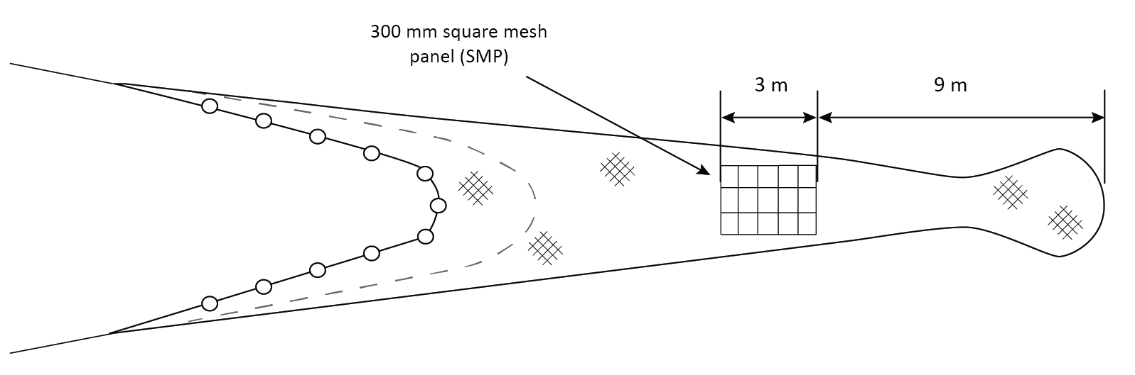

During the first set of trials reductions of total catches of haddock and whiting of 52% and 70% respectively were observed. Over 80% of the haddock and whiting caught were below the mcrs so these reductions apply primarily to fish below mcrs. Marginal increases in *Nephrops* and reductions in flatfish catches compared with the standard trawl were observed. Reductions in catches were consistent across size classes for haddock and whiting.

The 300mm smp was further tested against a SELTRA sorting box codend in 2016 on board the mfv “Stella Nova”. The results of these trials showed the SELTRA performed better than a standard 300 mm SMP achieving further reductions in catches of haddock and whiting below mcrs of 98% and 53%. However, the trawl with the 300mm smp retained relatively few fish below mcrs for both species and the losses of marketable haddock and whiting above mcrs was significantly reduced using the 300mm smp.

**SELTRA Sorting Box Trawl**

A number of assessments of the SELTRA sorting box (as shown in Figure xx) in the Irish Sea and Celtic Sea have been carried out in 2012, 2015, 2016 and 2017 on the mfvs “Celtic Warrior”, “Stella Nova” and “Ocean Breeze”. These trials have also been conducted as catch comparison trials comparing the SELTRA sorting box codend of 200mm and 300mm smp and 70mm codends with standard Regulation gear and in one case (as reported earlier) against a trawl fitted with a 70mm codend and 300mm smp.

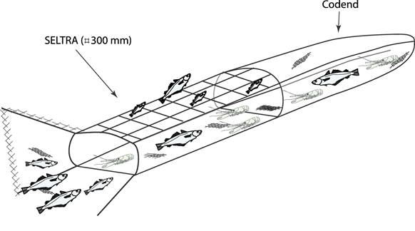

In all trials substantial reductions in fish catches in the SELTRA compared with a standard trawl or 300mm smp were observed. Reductions were 91% of haddock and 57% for whiting respectively. *Nephrops* catches improved by 9% in the SELTRA compared with a standard trawl (BIM, 2012, 2015, 2016 and 2017).

**Sorting Grids**

Testing of sorting grids (as shown in Figure 3 began in 2009 in the Celtic Sea on board the mfv “Supreme II”, in 2010 in the Irish Sea on the mfv “Mater Dei”. More recent work completed 2015 in the Irish Sea was completed on board the mfv “Our Lass II”. A standard Swedish fish sorting grid and a modified *Nephrops* sorting grid were tested during these trials on the basis of catch comparison experiments.

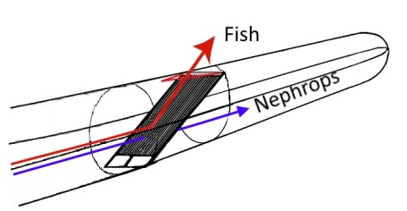

In all trials with the sorting grid, the results have shown that it reduces haddock and whiting catches by 60% and 70% respectively of haddock and whiting above ~ 23cm while reducing cod catches by almost 100%. As demonstrated in a number of studies, mixed results have been obtained with very small gadoids of less than ~20cm which can pass through the space between the bars of the grid. This is a particular issue in the Irish Sea but less of a problem in the Celtic Sea where such small haddock and whiting are not as predominant.

While it is possible to combine the grid with a more selective codend constructed in a bigger mesh size or constructed in square mesh, BIM trials of such measures have shown that they will reduce the catches of *Nephrops* significantly and potentially make the fishery uneconomic. Losses of larger *Nephrops* have been reported when using the Swedish grid. In the most recent trials a reduction of 11% in *Nephrops* > 31 mm compared with the control net was observed. Other trials have shown no reductions in *Nephrops* catches.

In conclusion the trials conducted have shown all three of the three gears to be selective for haddock, whiting and a lesser extent cod. The sorting grid and SELTRA have been shown to be most effective at reducing unwanted catches. However, they also have been shown to give significant reductions in marketable catches. The 300mm smp is less effective at reducing unwanted catches but has corresponding lower losses of marketable catch. None of these devices seem to significantly reduce the catch of *Nephrops*. It is therefore considered that these three gear options are a reasonable compromise between increased selectivity and maintaining economically viable fisheries. Fishermen may choose to use these gears depending on whether they have quota for bycatch species such as haddock, whiting and cod. In situations where they have little or no quota then the grid and SELTRA are more appropriate devices to continue fishing.

**Targeted whiting and mixed demersal fisheries**

In the other TR2 fisheries – the targeted whiting and mixed demersal fisheries - the results from some of the trials indicated above for the TR1 fisheries are directly relevant. As with the TR1 fisheries the focus has been on increases in codend mesh size, large mesh square mesh panels and the use of T90 or square mesh codends that have been shown to reduce unwanted catches of haddock. Trials have been carried out with both trawl and seine net gears. The relevant trials are outlined in Table 13 below.

|  |  |  |  |  |  |  |
| --- | --- | --- | --- | --- | --- | --- |
| Date | Vessel | Vessel Type | LOA | KW | Relevant gear combinations tested | Method Used |
| July 20101 | Providence II | OTB Twin-rig | 13m | 112Kw | 80mm  90mm  90mm + 120mm smp  100mm | Paired selectivity |
| July 20101 | Ludovic Geoffray | OTB  Twin-rig | 17m | 308Kw | 80mm  80mm+120mm smp  100mm+120mm smp | Paired selectivity |
| July 2011 | Ashrona | SSC | 18m | 260Kw | 100mm+110mm SMP | Alternate hauls |
| June 2012 | Ashrona | SSC | 18m | 260Kw | 100mm+100mm SMP | Alternate hauls |
| Sept 20122 | Foyle Warrior | OTB single-rig | 25m | 600Kw | 80mm+110mm smp  100mm + 100mm smp | Covered codend |
| Oct 20133 | Northern Celt | OTB single-rig | 22m | 600Kw | 80mm +140mm smp  100mm+ 160mm smp | Covered codend |
| April 20165 | Foyle Fisher | OTB twin-rig | 24m | 500kw | 80mm T90 | Twin trawl |

The first two sets of trials carried out on the Providence II and the Ludovic Geoffray (BIM, 2010), as reported under the TR1 fisheries, considered a range of increases in codend mesh sizes and also square mesh panels.

At the time of these trials the legal gear was 80mm codend mesh size (with no square mesh panel). These trials considered the effect of increasing mesh size from 80mm to 120mm primarily in the mixed demersal fishery. Table 14 shows the 50% retention length (L50) increases for haddock and for other associated species such as whiting and megrim with increasing mesh size. These results indicate that as mesh size increases the L50 for haddock increases slightly but even with a 100mm codend, the L50 remains below mcrs. For whiting and megrim L50 is above mcrs when codend mesh size increases to 90mm.

**Table 14 50% Retention lengths (L50) and selection ranges (SR) for haddock, whiting and megrim for selected codend mesh sizes**

|  |  |  |  |  |  |  |
| --- | --- | --- | --- | --- | --- | --- |
| Codend mesh size | Haddock (mcrs =  30cm) | | Whiting (mcrs = 27cm) | | Megrim (mcrs = 20cm) | |
| L50 | SR | L50 | SR | L50 | SR |
| 80mm | 24.21 | 11.21 | 26.41 | 121 | 27.62 | 12.72 |
| 90mm | 27.11 | 13.11 | 31.11 | 9.61 | 33.81 | 17.41 |
| 100mm | 281 | 11.91 | 361 | 141 | 34.61 | 111 |

1 Ludovic Geoffray, 2 Providence II

Further experiments were carried out on these two vessels with a range of codend and smp combinations as shown in Table 15. The results show that for haddock L50 was above mcrs with a combination of 90mm and 120mm smp and is well in excess of the L50 with a 100mm+120mm smp combination. All there gear combinations result in L50s in excess of the respective mcrs for whiting and megrim. For hake only data is available for the 90mm+120mm smp combination.

**Table 15 50% Retention lengths (L50) and selection ranges (SR) for haddock, whiting, megrim and hake for selected codend mesh sizes and smp combinations**

|  |  |  |  |  |  |  |  |  |
| --- | --- | --- | --- | --- | --- | --- | --- | --- |
| Codend/SMPcombination | Haddock (mcrs = 30cm) | | Whiting (mcrs = 27cm) | | Megrim (mcrs = 20cm) | | Hake (mcrs = 27cm) | |
| L50 | SR | L50 | SR | L50 | SR | L50 | SR |
| 80mm/120mm smp1 | 28.2 | 14.8 | 32.8 | 13.5 | 29.1 | 15.6 | No data | |
| 90mm/120mm smp2 | 34.5 | 18.3 | 37.2 | 9 | 33.2 | 14.6 | 32.3 | 17.8 |
| 100mm/120mm smp1 | 39.2 | 10.8 | No data | | 38.8 | 16.2 | No data | |

1 Ludovic Geoffray, 2 Providence II

The trials on the Foyle Warrior in 2012 were carried out in ICES VIIg in the directed whiting fishery and tested an 80mm codend and 110m square mesh panels as well as a 100mm codend with a 100mm square mesh panel (BIM, 2012). Table 16 below shows the L50s for haddock, whiting and hake for the two gear combinations tested in this trial.

**Table 16 50% Retention lengths (L50) and selection ranges (SR) for haddock, whiting and hake for selected codend mesh sizes and smp combinations**

|  |  |  |  |  |  |  |
| --- | --- | --- | --- | --- | --- | --- |
| Codend/SMPcombination | Haddock (mcrs =  30cm) | | Whiting (mcrs = 27cm) | | Hake (mcrs = 27cm) | |
| L50 | SR | L50 | SR | L50 | SR |
| 80mm/110mm smp | 33 | 14 | 32.1 | 6.61 | 31 | 12.8 |
| 100mm/100mm smp | 33.4 | 8.2 | 37.4 | 6.5 | 37.9 | 9.6 |

The results indicate that both combinations tested during this trial are selective for haddock with an L50 in excess of the mcrs. There was very little difference between the two gear combinations tested. Similarly for whiting and hake, the L50s observed are in excess of the mcrs for these species with the 80mm+110mm smp combination and well in excess of the mcrs with the 100mm+100mm smp combination.

Table 17 below shows the percentage of retained fish at the mcrs and also at different marketable sizes for whiting, haddock and hake above which all fish are routinely retained. Fish between this size and the mcrs are quite often discarded due to their low market value.

**Table 17 Total numbers of, haddock, whiting megrim and hake retained in the test codends relative to the total catch at mcrs and at selected market grades**

|  |  |  |
| --- | --- | --- |
|  | Percentage Retained | |
| 80mm +110 smp | 100mm + 100mm smp |
| Haddock at mcrs (30cm) | 37% | 26% |
| Grade 3 haddock (37cm) | 65% | 70% |
|  |  |  |
| Whiting at mcrs (27cm | 14% | 25% |
| Grade 3 whiting (32cm) | 50% | 14% |
|  | | |
| Hake at mcrs (27cm) | 65% | 30% |
| Hake at 1kg (50cm) | 98% | 93% |

The results show that the losses of marketable whiting and hake are more pronounced with the 100mm+100mm smp gear combination. Catches of marketable haddock are similar with both gears.

Of the trials carried out on the Northern Celt in 2013 (BIM 2013) and 2014 (BIM, 2014), only the tests with an 80mm+140 smp are relevant to the TR2 fisheries. This trial was carried out in the mixed demersal fishery where haddock is a bycatch. Table 18 shows the L50s observed for haddock, whiting and megrim.

**Table18 50% Retention lengths (L50) and selection ranges (SR) for whiting, haddock and megrim for selected codend mesh sizes and smp combinations**

|  |  |  |  |  |  |  |
| --- | --- | --- | --- | --- | --- | --- |
| Codend/SMPcombination | Haddock (mcrs =  30cm) | | Whiting (mcrs = 27cm) | | Megrim (mcrs = 20cm) | |
| L50 | SR | L50 | SR | L50 | SR |
| 80mm/140mm smp1 | 25 | 15 | 47 | 16 | 21.5 | 9.9 |

The results indicate that in this trial, this gear combination did not appear to be selective for haddock or for megrim but was highly selective for whiting. It was observed that 65% of haddock < mcrs were still retained with this gear combination. However, during this trial the number of haddock greater than 25cm observed was very low and the result may be an underestimate.

There have been two trials on the seine net vessel MFV “Ashrona” in the targeted whiting fishery. These trials were carried out in July 2011 and June 2012 and tested a 100mm codend+110mm square mesh panel and a 100mm codend+100mm smp against a standard 100mm codend. These trials were conducted as a catch comparison experiment using the alternate haul method. Seine nets are regarded as being more selective than trawl gears although a review by ICES in 2011 did not find any appreciable difference based on the results of a number of separate selectivity experiments with this type of gear. The results from the Ashrona trials are summarised in Table 19.

**Table 19 Total numbers of haddock, whiting and megrim retained in the test codends relative to the total catch at mcrs**

|  |  |  |  |  |  |  |
| --- | --- | --- | --- | --- | --- | --- |
| Codend/SMPcombination | Haddock (mcrs =  30cm) | | Whiting (mcrs = 27cm) | | Hake (mcrs = 27cm) | |
| <mcrs | >mcrs | <mcrs | >mcrs | <mcrs | > mcrs |
| 100mm/110mm smp1 | 41% | 40% | No data | 19% | No data | 51% |
| 100mm/100mm smp2 | 42% | 98% | No data | 64% | No data | 102% |

1 Ashrona – July 2011; 2 Ashrona June 2012

The results from this trial show that a 100mm codend without a smp fitted catches large quantities of haddock < mcrs. The addition of the 100mm or 110mm smp improves selectivity quite significantly and reduces the haddock retained below mcrs. Both gear combinations lead to losses of marketable fish. These losses are highest with the 110mm smp.

The results from Irish trials in 2015 with T90 codends of 80mm mesh size are relevant to the TR2 fisheries. In these trials catches of undersized whiting were reduced by 60% (BIM, 2015). However, catches of undersize haddock did not decrease. Research conducted by the French institute, IFREMER in the Celtic Sea has demonstrated that a larger 100 mm T90 mesh substantially reduces catches of undersize haddock but also results in 20 to 30% losses in market sized whiting. Further testing of this type of codend is required to identify the best compromise mesh size for T90 codends.

In conclusion, based on the limited number of trials carried out it seems reasonable that continued use of a smaller codend mesh size than in the TR1 fisheries is appropriate, given the catch composition and reliance on whiting and at certain times of the year, hake. Further increases in selectivity may make this fishery uneconomic given the likely losses of marketable catch. In the mixed demersal fisheries which operate largely outside the Celtic Sea Protection Zone, given catches of haddock are much lower than in other fisheries and the target species in these fisheries are primarily anglerfish and megrim there seems little merit in requiring a smp to be fitted.

**Conclusions**

The main conclusions are as follows:

* The discard rates of haddock in both TR1 and TR2 fisheries in the Celtic Sea are high (~50%). Therefore in line with the Council Declaration on selectivity and also as haddock has been identified as a high risk choke stock it is important to improve selectivity in fisheries catching haddock in the Celtic Sea.
* In order to allow the vessels involved adapt to using more selective gears this de minimis exemption is important to allow limited discarding of residual unwanted catches that are likely to remain.
* Improving selectivity in fisheries targeting haddock should result in increased catches of larger fish with a higher economic value which will help to offset any short-term losses in marketable catch associated with using these more selective gears.
* In the TR1 mixed gadoid fisheries the current regulation gear inside the Celtic Sea Protection Zone of 100mm+120mm smp where the majority of landings are taken in this fishery is selective for whiting but less so for haddock. Based on the results of the trials increasing codend mesh size and maintain the existing 120mm smp would seem appropriate. The alternatives would be look at T90 mesh in the codend and extension which has also been shown to improve selectivity for gadoids. Any increases in selectivity will undoubtedly reduce the marketable catch of whiting, hake and flatfish species.
* In the other TR1 fisheries, haddock catches are much lower and there is less of necessity to increase selectivity overly in the short term. The combination of losses of haddock and other associated species such as megrim, whiting and hake resulting from increasing selectivity would make these fisheries uneconomic.
* In the TR2 *Nephrops* fisheries moving from 80mm+120mm smp to using an 80mm codend with a 300mm smp, SELTRA box codend or sorting grid will increase the selectivity for haddock significantly without reducing catches of *Nephrops* unduly. Based on the results of the trials the use of any of these devices will reduce haddock catches by between 50-90%.
* Based on the results from the trials and model predictions he use of a 100mm+100mm smp gear combination in the TR2 directed whiting fishery will give an estimated L50 of between 31-33cm for haddock and an L50 for whiting of 35-37cm.
* In the other TR2 mixed demersal fisheries, where catches of haddock are much lower an increase in codend mesh from 80mm to 100mm would have limited impact for haddock but would give a general improvement in these fisheries where discarding of other species such as hake can be significant.