De minimis proposal for undersized whiting in the TR2 nephrops trawl fishery (Irish Sea)

Summary of De Minimis
Species | Whiting in the Irish Sea
Fishery | Directed nephrops fishery operating with demersal trawls with cod end between 70 and 99mm in the Irish Sea.
% de minimis requested | 5% of the catches of whiting by the fleet using highly selective TR2 gears in the Irish sea.
Fleet involved | 146 NI vessels  169 IE vessels
Catches and discards | Catches by the TR2 fleet in 2016 were:  whiting: 3t landed 558t discarded (UK)  2t landed and 535t discarded (IE)
Justification | Increasing selectivity is difficult to achieve without resulting in significant economic losses of target fishery
Other comments | All vessels operate one of a range of selective gears; these gear options are subject to stepwise review and improvement.

Background
In the framework of the landing obligation in accordance with Article 15 of regulation (EU) No1380/2013 a de minimis exemption is requested for catches of undersized whiting taken by the demersal trawl fishery targeting Nephrops, using cod ends of between 70-99mm in the Irish Sea.
De minimis levels of 5% for whiting of the total annual catch of each species by vessels using highly selective demersal trawls with cod ends of between 70-99mm in the Irish Sea are requested.
A de minimis is sought on the basis that scientific evidence demonstrates additional selectivity cannot be easily achieved without compromising the current target fishery. Additional selectivity will have increasing impact on the target catch removing the economic benefit of the fishery without significant improvement in discard reduction. The Northern Ireland and Irish fleets already operate with a number of Nephrops gears that have been assessed and found to be highly selective for cod and other gadoids.
The Nephrops fishery is the mainstay of the Northern Ireland and Irish fleets. There are few alternatives for diversification open to these fleets. Substantial work has been undertaken in the last 5 years (since 2013) to improve the selectivity of these nets, with a focus on reducing unwanted catches of large cod, and other gadoids. This has had additional benefit for reducing discards of haddock and whiting but the elimination of undersized whiting has proven difficult due to size selection overlap with the target species.
Catch and Discard Data
In 2016 STECF data shows total catches of whiting in VIIa by TR2 vessels were 1,099 tonnes with landings of 5 tonnes and discards of 1,093 tonnes. This gives a discard rate of 99%. Total Irish catches in 2016 were recorded as 537 tonnes (2 tonnes landings and 535 tonnes discards). This is all fish below MCRS.
Discard analysis from the Northern Ireland fleet is undertaken by AFBI. Landings were 561 tonnes with 3 tonnes of landings and 558 tonnes of discards of which 89% of discards are fish below MCRS.
Collated fleet discards for the TR2 fleet in 2016 show whiting catches continue to be a particular issue for this fishery and present a significant choke risk. There remain significant proportions of undersized catches of whiting which, in spite of the adoption of highly selective gears present a choke to the Nephrops fishery. Based on this data a summary of the proposed de minimis exemptions is shown in Table 1.
Country | Exemption applied for (species, area, gear type) | Species as a bycatch or target | Number of vessels subject to LO | Landings (by LO subject Vessels) | Estimated Discards | Estimated Catch | Discard Rate | Estimated de minimis volumes (5%)
UK | Whiting  VIIa  TR2 | Bycatch | 146 | 3 | 558 | 561 | 99% | 28
IE | Whiting  VIIa  TR2 | Bycatch | 169 | 2 | 535 | 537 | 99% | 27

Description of the species and fisheries.

Whiting Stock in Division 7a (Irish Sea): ICES advises that this stock remains at very low size, SSB is below B_{lim} since the mid 1990’s, and recruitment is similarly low. Fishing pressure has varied greatly and the stock is currently fished above F_{MSY}. There is a high level of discarding of this stock, primarily from the nephrops fishery.
The low TAC and high catches of undersized whiting represents the greatest choke risk to the nephrops fishery.

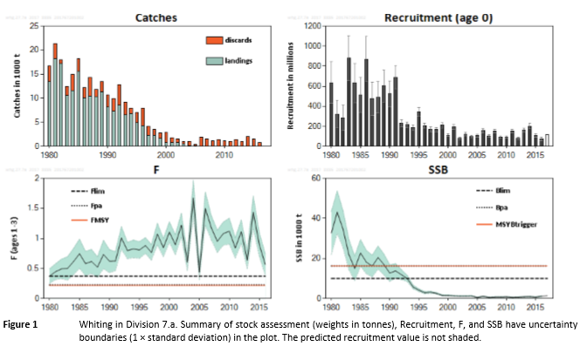

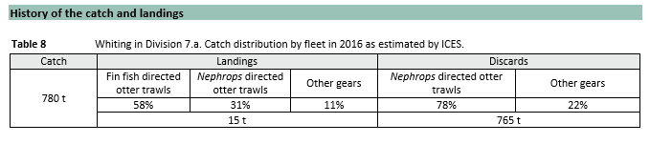

Current regulations
In addition to the current national and European gear requirements , Northern Ireland continues to operate a number of cod conservation measures to protect the recovering cod stock in the Irish Sea; fisheries must continue to demonstrate low cod mortality. This is achieved through use of a seasonal closure, mandatory use of highly selective gears in both TR1 and TR2 mesh ranges and extensive scientific observer coverage.
The permitted gears have been subject to scientific evaluation on behalf of the Northern Ireland fleet by the Agri-Food Biosciences Institute (AFBI) and have been demonstrated to be highly selective, reducing catches of cod to very low levels. These gears, where possible, have also been assessed by STECF. These measures were first introduced in 2013. Table 1 identifies the reduction achieved in 2013 trials. Additional gears have been included on satisfactory assessment. A full list of the currently accepted gears is in Annex I.

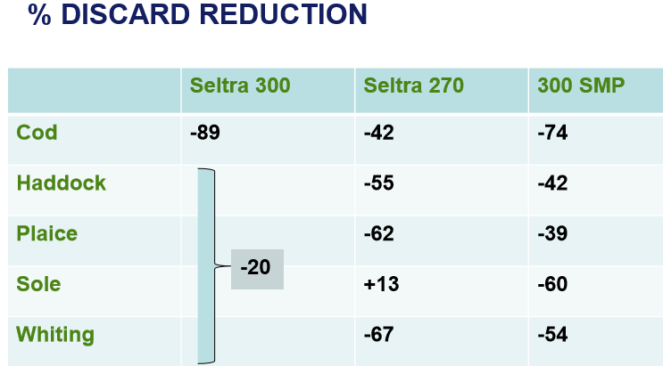

Table 1 Catch reduction by gear type in 2013 NI gear trials
Similarly Ireland has made it mandatory for Irish vessels targeting Nephrops to use highly selective gears. This is linked to the cod recovery plan (Articles 11 and 13 of Regulation (EC) 1342/2008). The gears allowed are a 300mm SMP, SELTRA box codend or a rigid sorting grid with 35mm bar spacing. In addition Ireland has increased the mesh size in Nephrops fisheries from 70mm to 80mm from 1 January 2017 under SI 510 of 2016

Current selectivity measures - UK
The key issue is the large volume of undersized whiting. Discarding at requested de minimis levels will not remove all unwanted catches; landings of undersized fish will occur and additional selectivity or avoidance is required. A number of the current selectivity measures are recognised to be more effective for larger fish, i.e. SMPs.
AFBI provide a synopsis of recent gear trials and the improvements in selectivity in the Irish Sea with a focus on the impact on whiting stocks and of work planned for 2018 to reduce catches further. Attached Annex. The same report also looks at the current discard estimates, and possible spatial management options. In summary;
- Temporal and season patterns of whiting by-catch are complex and show high levels of inter-annual variability.
- A significant body of work exists relating to gear selectivity developments in the Irish Sea Nephrops fishery.
- The current gear used by the industry has been developed with the aim to reduce by-catch of a range of species.
- Trials of gear known to work in other sea areas have shown highly variable results given the characteristics of both the Nephrops/fish community and the character of the fishing fleets pursuing these fisheries.
- Commitment to further developments is evident and trials for novel solutions are on-going.

The large annual variation makes a spatial closures difficult; conversely temporary closures at peak times of highest discard volumes coincide with peak nephrops activity; closures would have a larger impact on the target fishery at this time.
Annex I provides the list of currently approved gear types for TR2 fisheries for the Northern Ireland fleet. As noted in the initial STECF review (PLEN-13-03) there are a number of options possible to achieve a similar reduction of cod catches. The majority of the NI fleet utilise the 300mm SMP option, with either 80 or 70mm cod end (see Table 1 for impact). Additional examination of the 300mm SMP gear has been undertaken by BIM.
As previously noted the initial focus of these regulated gears has been the reduction of cod catches to reduce the catch of cod to less than 1.5% of the overall catch but have also provided a reduction of catches of other gadoids.
In their trial of the 300mm SMP in the Irish Sea BIM identify a catch reduction across the size range (see graph below) without a reduction of nephrops catch (BIM report 52% whiting reduction).
The limitations of SMPs as the only selective gear are well documented; they offer different size selection depending on their location (i.e. Vogel 2017) or are more effective at particular seasons, relating to species condition (Fryer 2014) or stock densities. SMPs alone will not reduce the catches of smaller whitefish.

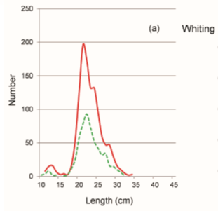
Reduction of catches in 300mm SMP Trial (BIM)

Selectivity in the codend
Other selectivity options need to be developed; including changes to the cod end. As with all selectivity options there are always limits in applicability; conditions vary across fisheries so care must be taken in extrapolating results. There already exist a number of assessments of the selectivity of cod ends, and AFBI (Annex III) provide a review of applicable trials of a 90mm cod end. AFBI are currently undertaking further sea trials of such a gear to determine fleet specific impacts.
BIM (2015b) have already undertaken a number of trials of cod end sizes including a 90mm (as proposed by the Commission in the preparation of the 2019 Fishing Opportunities). The authors note that increases in cod end mesh size beyond 80mm resulted in an approximate doubling of economic loss of the other components of the catch for a small change in nephrops selectivity. They conclude that in the short term that an increase to 90mm or 100mm is unlikely to be economically feasible: However the authors consider that the reduction of the whiting catch may make this option preferable for some vessels (targeting whole nephrops). This paper suggests there is a step change in selectivity between 80mm and 100mm- there are minimal losses in moving to 80mm, but more significant losses after 80mm. The authors identify a 20% loss for both 90mm and 100mm cod ends (compared to a 70mm cod end).
Again caution must be applied in transferring the results of one experiment to other. The same trial reported inconsistency with increasing cod ends on the catch of whiting. Catches reduced in the 90mm but increased again in the 100mm cod end.
AFBIs review (Annex III) provides some estimations of the likely reduction in catch from an increase in the cod end mesh size between the current 70 & 80mm gears to a 90mm. These figures are consistent with BIM (2015b) giving estimates of a reduction of between 10-20% of nephrops catch. AFBI identify from their meta-analysis a loss of 13% with a 10mm increase in cod end mesh size. This equates to approximately 1000t. This could be considered uneconomic for this fleet. Recent catches for the NI fleet in Area 7a are tabled below. It must be highlighted that the NI nephrops fleet is particularly dependant on nephrops and has limited diversification options.

Year | 2013 | 2014 | 2015 | 2016
nephrops (t) | 6344 | 5798 | 6639 | 5845
Table 3: Catches by NI fleet in Area 7a.

Current selectivity measures – Ireland

In the TR2 fisheries in the Irish Sea the main focus of Irish selectivity work has been in improving selectivity in the directed Nephrops fisheries. The trials have considered increasing codend mesh size, square mesh and other types of escape panels as well as the use of rigid sorting grids.

The vessels operating in this fishery in the Irish Sea have been subject to the Landing Obligation since 2015 for Nephrops. Whiting has not been subject to the Landing Obligation as yet. ICES report that discarding of whiting in the Nephrops fisheries in the Irish Sea is high. There is some indication from the ICES advice from 2017 of a reduction in the level of discards which may be as a result of the introduction of more selective gears into the fishery by both the UK and Ireland.

Since 2009, eleven studies have been carried out by Ireland testing the selectivity of a range of gear combinations in directed Nephrops fisheries. Much of this work has been carried out in the Nephrops fisheries in the Irish Sea. Table 4 summarises the trials conducted and the gear combinations tested.

Date | Vessel | Vessel Type | LOA | KW | Gear combinations tested | Method Used
March/April 2009 | Supreme II | OTB Twin-rig | 24.7 | 421 | Swedish sorting grid  Inclined separator panel  100mm codend + 160mm SMP | Twin-trawl
June 2009 | Ocean Pioneer | OTB twin-rig | 22.4 | 440 | 100mm + 200mm SMP  Coverless Trawl | Twin-trawl
April/May 2012 | Celtic Warrior II | OTB twin-rig | 24.9 | 370 | SELTRA Sorting Box (200mm smp) | Twin-trawl
August 2014 | Stella Nova | OTB quad-rig | 23.5 | 441 | 70mm codend + 300mm smp | Quad-rig
July 2015 | Celtic Warrior II | OTB quad-rig | 24.9 | 370 | 80mm codned  90mm codend  100mm codend | Quad-rig
September 2015 | Stella Nova | OTB quad-rig | 23.5 | 441 | SELTRA sorting Box (300mm smp) | Quad-rig
September 2015 | Our Lass II | OTB quad--rig | 22 | 484 | Swedish grid  Nephrops Sorting grid + 70mm codend  Nephrops Sorting grid + 75mm codend | Quad-rig
February 2016 | Stella Nova | OTB quad-rig | 23.5 | 441 | 45mm square mesh codend  55mm square mesh codend  65mm square mesh codend | Quad-rig
September 2016 | Ocean Breeze | OTB Twin-rig | 18 | 224 | SELTRA Sorting Box (300m smp) | Twin-rig
December 2016 | Ocean Breeze | OTB Twin-rig | 18 | 224 | SELTRA Sorting Box (300m smp) with adapter section | Twin-rig
April 2017 | Ocean Breeze | OTB Twin-rig | 18 | 224 | SELTRA Sorting Box (300m smp) with adapter section and inclined panel | Twin-rig

The most relevant trials to consider in the context of this de minimis exemption are those with 300mm square mesh panels, the SELTRA box codend and the Swedish sorting grid. All three of these gears are recognised as highly selective gears and currently Irish vessels targeting Nephrops in the Irish Sea must use one of these three gears. A summary of the results observed with these gears is provided in the following sections.
300mm Square Mesh Panels
Assessment of a 300 mm square-mesh panel (as shown in Figure xx) in the Irish Sea Nephrops fishery was carried out in 2014 and again in 2016 (compared to a SELTRA sorting box) on board the mfvs “Stella Nova” and “Ocean Breeze”. These trials were carried out as catch comparison experiments testing against the current legal gear of 80mm codend with 80mm smp required in the Irish Sea.

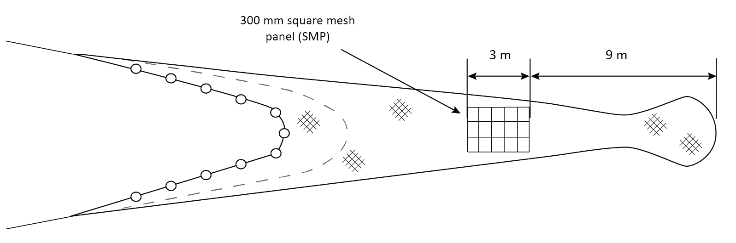
During the first set of trials reductions of total catches of haddock and whiting of 52% and 70% respectively were observed. Over 80% of the haddock and whiting caught were below the mcrs so these reductions apply primarily to fish below mcrs. Marginal increases in Nephrops and reductions in flatfish catches compared with the standard trawl were observed. Reductions in catches were consistent across size classes for haddock and whiting.
The 300mm smp was further tested against a SELTRA sorting box codend in 2016 on board the mfv “Stella Nova”. The results of these trials showed the SELTRA performed better than a standard 300 mm SMP achieving further reductions in catches of haddock and whiting below mcrs of 98% and 53%. However, the trawl with the 300mm smp retained relatively few fish below mcrs for both species and the losses of marketable haddock and whiting above mcrs was significantly reduced using the 300mm smp.
SELTRA Sorting Box Trawl
A number of assessments of the SELTRA sorting box (as shown in Figure xx) in the Irish Sea and Celtic Sea have been carried out in 2012, 2015, 2016 and 2017 on the MFV’s “Celtic Warrior”, “Stella Nova” and “Ocean Breeze”. These trials have also been conducted as catch comparison trials comparing the SELTRA sorting box codend of 200mm and 300mm smp and 70mm codends with standard Regulation gear and in one case (as reported earlier) against a trawl fitted with a 70mm codend and 300mm smp.
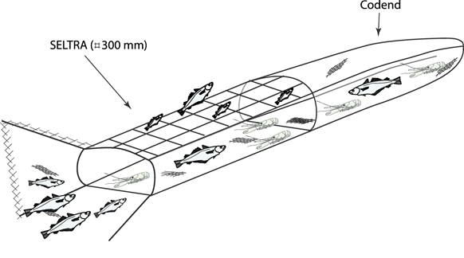
In all trials substantial reductions in fish catches in the SELTRA compared with a standard trawl or 300mm smp were observed. Reductions were 91% of haddock and 57% for whiting respectively. Nephrops catches improved by 9% in the SELTRA compared with a standard trawl (BIM, 2012, 2015, 2016 and 2017).
Sorting Grids
Testing of sorting grids (as shown in Figure below) began in 2009 in the Celtic Sea on board the MFV “Supreme II”, in 2010 in the Irish Sea on the MFV “Mater Dei”. More recent work completed 2015 in the Irish Sea was completed on board the MFV “Our Lass II”. A standard Swedish fish sorting grid and a modified Nephrops sorting grid were tested during these trials on the basis of catch comparison experiments.
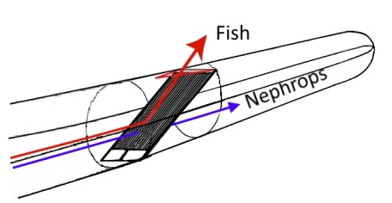

In all trials with the sorting grid, the results have shown that it reduces haddock and whiting catches by 60% and 70% respectively of haddock and whiting above ~ 23cm while reducing cod catches by almost 100%. As demonstrated in a number of studies, mixed results have been obtained with very small gadoids of less than ~20cm which can pass through the space between the bars of the grid. This is a particular issue in the Irish Sea where such small haddock and whiting are not as predominant.
While it is possible to combine the grid with a more selective codend constructed in a bigger mesh size or constructed in square mesh, BIM trials of such measures have shown that they will reduce the catches of Nephrops significantly and potentially make the fishery uneconomic. Losses of larger Nephrops have been reported when using the Swedish grid. In the most recent trials a reduction of 11% in Nephrops > 31 mm compared with the control net was observed. Other trials have shown no reductions in Nephrops catches.

Other Options:
The TR2 fleet will need access to sufficient whitefish quota to cover their remaining by catches. This will need to be addressed at individual vessel level. This is particularly true for haddock, and to a lesser degree cod. For whiting, for which there is a minimal quota this option is not possible.

De Minimis levels required
A de minimis level of 5% for whiting of the total annual catch of each species by vessels using highly selective demersal trawls with cod ends between 70 and 99mm in the Irish Sea is requested. An estimation of the de minimis volumes that would have been applicable based on 2016 figures is below.

TR2 | Discard (t) | Landing (t) | Discard Rate % | % Below MCRS | Total Catch (t) | Percentage requested | De Minimis Volume (t) | Volume of u/s discards (t)
WHG UK | 557.8 | 3 | 99.5 | 89 | 560.8 | 5% | 28.0 | 496.4
WHG IE | 535 | 2 | 99.5 | 100 | 537 | 5% | 27 | 510

Conclusions
- The selectivity measures adopted by the NI fleet have made significant reductions of the unwanted catch of cod, haddock and whiting. Removal of small whiting and haddock while maintaining target catches of nephrops in particular remains a significant challenge.
- The trials conducted by Ireland have similarly shown the sorting grid, 300mm smp and the SELTRA to be selective for haddock, whiting and a lesser extent cod. The sorting grid and SELTRA have been shown to be most effective at reducing unwanted catches. However, they also have been shown to give significant reductions in marketable catches. None of these devices seem to significantly reduce the catch of Nephrops.
- The current highly selective measures are making a significant contribution to whiting discards reduction but due to the current size and age structure of the 7a whiting stock (fish are suspected to be maturing at a smaller size) recovering the stock to MSY levels will be long term undertaking, no matter what conservation measures are adopted.
- The requested de minimis would form part of a package of measures under development to address chokes in the Irish Sea.
- The fleet needs time to develop technical and management solutions further.
- SMP’s have size and behaviour selectivity, smaller fish are less likely to escape, additional changes in the cod end have significant impact on the target catch. This needs to be further quantified for the Irish Sea.
- Increasing the cod end further results in additional loss of the target species for little additional reduction of whiting catch. There is no single technical measure that will remove all the unwanted catches. Numerous mechanisms need to be investigated together and alternative management options examined.
- Work on improving selectivity needs to continue: the requested de minimis levels will reduce the need to land unwanted catches of whiting and act as a target for selectivity measures to achieve.
- The requested level of de minimis will not remove all unwanted catches for whiting.

Next steps and future research
AFBI are examining the use of a 90mm in the Northern Ireland fleet; they are also continuing sea trials of other selectivity options. The outcomes will inform future permitted gear options. This is an on-going process, and will require continual fine tuning to the conditions of the Irish Sea.

References
BIM, 2009a. Summary report of gear trials to support Ireland’s submission under Articles 11 and 13 of Regulation 1342/2008 Nephrops fisheries VIIa & VIIb-k. NDP Project 09.SM.T1.01. May 2009. 9pp.
BIM, 2009b. Summary report of gear trials in Nephrops fisheries in VIIb-k. NDP Project 09.SM.T1.01. June 2009.12pp.
BIM, 2012. Summary report of SELTRA sorting box trials in the Irish Sea Nephrops Fishery. BIM Gear Technology Report. 8pp.
BIM, 2014a. Assessment of a 300 mm square-mesh panel in the Irish Sea Nephrops fishery. BIM Gear Technology Report. 5 pp.
BIM. 2014b. Catch comparison of Quad and Twin-rig trawls in the Celtic Sea Nephrops fishery, BIM Gear Technology Report. 4 pp.
Cogrove, R., Browne, D., McDonald, D. and Tyndall, P. 2015. Assessment of diamond cod-end mesh size on catch composition in a Celtic Sea Nephrops trawl fishery. BIM Gear Technology Report. 7 pp.
Cosgrove, R., Browne, D., McDonald, D., Curtin, R., and Keatinge, M., 2015. Assessment of an increase in cod-end mesh size in the Irish Sea Nephrops fishery. Irish Sea Fisheries Board (BIM), Fisheries Conservation Report. 16 pp.
Cosgrove, R., Browne, D., and McDonald, D., 2016a. Assessment of rigid sorting grids in an Irish quad-rig trawl fishery for Nephrops. Irish Sea Fisheries Board (BIM), Fisheries Conservation Report. 9 pp. Irish Sea Fisheries Board (BIM), Fisheries Conservation Report. 8pp.
Cosgrove, R., Browne, D., and Tyndall, P., 2016b. Assessment of square mesh cod-ends in an Irish Nephrops fishery. Irish Sea Fisheries Board (BIM), Fisheries Conservation Report. 15pp.
Fryer (2014). A meta-analysis of haddock size-selection data, Robert John Fryer, Finbarr Gerard O’Neill & Alexius Edridge. Fish and fisheries, December 2014
McHugh, M. Browne, D., Oliver, M., Tyndall, P. and Cosgrove, R. 2017. Assessment of an inclined panel and flotation devices in the SELTRA. Irish Sea Fisheries Board (BIM), Fisheries Conservation Report. 10pp.
Tyndall, P., Oliver, M., Browne, D., McHugh, M., Minto, C., and Cosgrove, R. 2017. The SELTRA sorting box: A highly selective gear for fish in the Irish Nephrops fishery. Irish Sea Fisheries Board (BIM), Fisheries Conservation Report, February 2017. 12 pp.BIM. 2014a. Assessment of a 300 mm square-mesh panel in the Irish Sea Nephrops fishery, BIM Gear Technology Report. 5 pp
Vogel et al (2017): Improving gear selectivity of whiting (Merlangius merlangus) on board French demersal trawlers in the English Channel and North Sea, Fisheries Research V193, pp 207-216

http://www.sfpa.ie/Portals/0/legislation/fisheries%20conservation/statutory%20instruments/2016/SI%20510%20of%202016%20Sea%20Fisheries%20(Codend%20Mesh%20Size)%20Regulations%202016.pdf).
http://www.bim.ie/media/bim/content/publications/BIM,Report,Assessment,of,a,300,mm,square-mesh,panel,in,the,Irish,Sea,Nephrops,fishery,Nov,2014.pdf Assessment of a 300mm square-mesh panel in the Irish Sea Nephrops Fishery. BIM report pp5 (2014? no date on report)

