**Annex**

**De minimis request for pelagic species under landing obligation for demersal vessels using bottom trawls (OTB, OTT, PTB) in ICES subarea 6 and 7b-k.**

In the framework of the landing obligation in accordance with article 15 of regulation (EU) N° 1380/2013, a de minimis exemption obligation is requested for pelagic species caught with demersal vessels using bottom trawls (OTB, OTT, PTB) in ICES subarea 6 and 7b-k, up to 7% in 2019 and 2020 and 6% after 2020 of the total annual catches of pelagic species caught in demersal fisheries

The request for an exemption for de minimis is based on article 15.c.i), due to difficulties to further increase selectivity in this mixed fishery, and on article 15.c.ii), due to disproportionate costs a total application of the landing obligation would cause in this fishery. The fleet is particularly vulnerable for the risk of commercial catch losses an improvement in selectivity would cause.

Summary

Motive 1

Definition of the species 2

Definition of the management unit 3

Specifying de minimis volume 5

Reference 7

Annexes 8

### Motive

Vessels having a mixed activity catch simultaneously a diversity of species during the same fishing operation. They are depending financially on several species (whiting, haddock, cod, megrims, cephalopods) but also some pelagic species which can be spatially and temporally related. Thus, it is very difficult to improve selectivity without causing significant commercial losses.

This difficulty is even truer regarding the differences of those species morphology. Moreover, even with all scientists’ efforts on developing mixed species models, it is for now unreal to find the appropriate balance between fishing opportunity taking into account technical and biological interactions. That is why, besides the description of choke species issues linked to this activity (mixed fisheries), it is highly necessary to establish suitable solutions.

This specificity of mixed demersal fisheries justifies this exemption request due to this difficulty to improve the selectivity. Several results can attest of commercial catch losses link to selective gear tested until now on mixed gadoids fishery in the English Channel (SELECCAB, SELECMER…). For example, the SELECMER program reveals commercial losses between 30% and 36% (pages 49, 54, 59) with the use of different selective devices aiming to reduce cod and small whiting catches (selective grid, eliminator trawl, square mesh, etc.).

Therefore, there are situations where TAC cannot be entirely consumed without overconsuming the TAC of another stock exploited simultaneously.

In addition to those situations of choke species, landing application enforcement may generate disproportionate cost due to hold overloading and increase the sorting time by the crew. Those arguments justify this de minimis request also for disproportionate costs. Some studies demonstrate those aspects such as EODE program *(Balazuc et al. 2016)*. According to the study, in bottom trawler case, total landing obligation enforcement would cause a workable time increase on board of around 30% to 60% depending on vessel size. Besides, 20% of fishing trip could be concerned by hold overloading issues.

This specificity of mixed demersal fisheries justifies this exemption request due to this difficulty to improve the selectivity. This de minimis request aims at giving some flexibility needed for fishermen, exercising bottom trawler metier, to implement the landing obligation.

Regarding the justification below, member states propose the following exemption: “On the basis of scientific evidence and rationale provided in Annex XIII the NWW group recommends that by way of derogation from Article 15(1) of Regulation (EU) No 1380/2013, the following quantities may be discarded: for mackerel, horse-mackerel, herring, boarfish and greater silver smelt combined, up to a maximum of 7 % in 2019 and 2020 and up to a maximum of 6% in 2021 of the total annual catches of these species by vessels using bottom trawls (OTB, OTT and PTB) in ICES subarea 6 and 7b-k."

*Those percentages can be revised if necessary.*

### Definition of the species

All pelagic fish under landing obligation are concerned by this exemption. Pelagic fish inhabit the water column (not near the bottom) of coasts, open oceans, and lake *(National Ocean Service).*

Below, the states of the stocks affected by this exemption, according to ICES:

- Mackerel (subareas 1–8 and 14, and in Division 9.a): ICES advises that when the MSY approach is applied, catches in 2018 should be no more than 550 948 tonnes. The spawning-stock biomass (SSB) is estimated to have increased in the late 2000s and has remained above MSY Btrigger since 2008. The fishing mortality (F) has declined from high levels in the mid-2000s, but remains above FMSY. Discarding is known to take place, but is only quantified for part of the fisheries; the proportion of the landings covered cannot be calculated. Partial discard estimates are included in the assessment and overall discarding is assumed negligible.

- Horse-mackerel (Subarea 8 and divisions 2.a, 4.a, 5.b, 6.a, 7.a–c, and 7.e–k): ICES advises that when the MSY approach is applied, catches in 2018 should be no more than 117 070 tonnes. The stock and the fishery are very dependent on occasional high recruitments. Recruitment from 2002 onwards has been low; however, recruitment in the last three years is above the geometric mean (1983–2016). In recent years, SSB has been declining and is currently the lowest observed in the time-series, below MSY Btrigger. Fishing mortality increased from 2007, but dropped in 2015–2016 and is currently below FMSY.

- Boarfish (subareas 6–8): ICES advises that when the precautionary approach is applied, catches should be no more than 21 830 tonnes in each of the years 2018 and 2019. The relative stock biomass was stable until 2009, and then increased in 2010–2012 before declining rapidly in 2013 and 2014. Since 2014, relative biomasses have been stable but lower than previously.

- Herring (Subarea 4 and divisions 3.a and 7.d, autumn spawners): ICES advises that when the European Union (EU)–Norway management strategy is applied, catches in 2018 should be no more than 517 891 tonnes, including 491 355 tonnes for the A-fleet. Spawning-stock biomass (SSB) fluctuated between 1.1 and 2.3 million tonnes from 1997 to 2016, in all years above Bpa. Fishing mortality (F) has been below FMSY since 1996. Since 2003, recruitment (R) has been low despite the large size of the stock. However, the 2014 recruitment was strong and has contributed to the increase in the spawning stock.

### Definition of the management unit

**Characteristics of the TR2 fishery and its activity**

The trawlers with a codend mesh size range 80-100mm is the fishery with second highest effort in Celtic Sea, accounting for 18% of the total effort. It is less widespread than the TR1, and the main 13 fishing areas are localized in ICES 7e, close to the English and French shores and in 7g, close to the Irish shore. The TR2 fishery in the Celtic Sea is mainly characterized by: 1) fishery for Norway lobster (termed ‘Nephrops’) operated mainly by Irish trawlers. There are significant Nephrops fisheries in the Smalls, Labidie and Porcupine bank that are not shown in the effort maps; 2) mixed fishery targeting anglerfish, gadoid species and non-quota species (cuttlefish and squid), taking place in VIIe close to the English and French shore; 3) Spanish-mixed fishery (otter trawl with codend mesh size 70-99mm) targeting flatfish, principally megrims and anglerfish, with hake as one of the main by-catches. Effort is distributed on shallow waters of Grand Sole and Porcupine Bank fishing mainly in Division 7j. According with the STECF data, most of the TR2 effort is mainly operated by English and French vessels, however most of the Spanish effort in the Celtic Sea are TR2 and is likely to be underestimated due to a lack of data.

The French vessels that would be concerned are mainly bottom otter trawlers. In 2016, 152 vessels were having this activity, mainly in the Western channel (Cornou *et al.* 2017).

**Composition of catches, landings and discards**

When they are targeting demersal species, bottom trawlers are catching a group of varied species, which several are under TAC management: nephrops, anglerfish, haddock, etc. but sometimes also pelagic species, such as horse-mackerel, mackerel, herring and boarfish. Therefore, those species are potential choke species for those vessels. Based on STECF database we tried to establish a catch and discard profile for those vessels.

It is important to notice that data used are not always representative, thus an extreme care on the interpretation and use of the estimates presented below is needed. The nonrepresentativness of discard data in general and the mixed character of those fisheries make hard to establish a profile discard and to estimate which quantity of every species could be discarded under the use of a de minimis as presented here. Nevertheless, it gives us a general idea based on the best data available for now (STECF data). It is also important to notice that discards and catches may highly vary from a year to another.

Based on the estimates, catches of mackerel, herring, horse mackerel and boarfish represent approximately 2% of overall catches. (Fig 1).

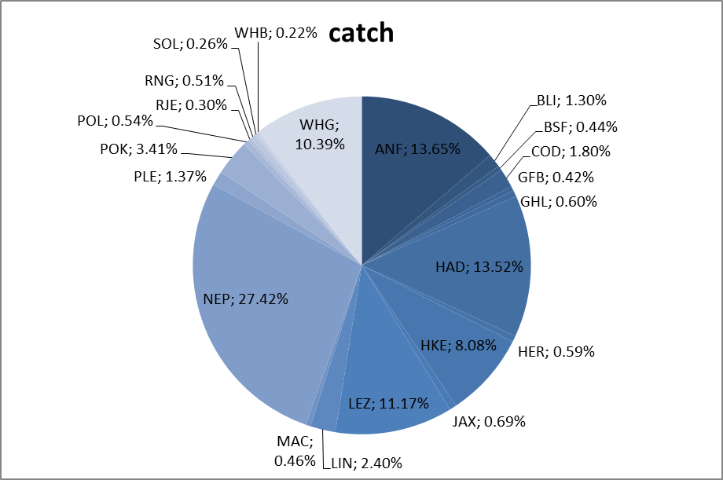

**Figure 1**: catch composition of TAC species in weight for bottom trawl fleet in ICES 6 and 7 b-k (*STECF data base - 2016*)

Discards represent approximately 24% of the total catches in 2016 of bottom trawler. The French data observer program indicates an overall discard rate for the French fishery of around 32% for vessel >18m in 2016 (Cornou *et al.*, 2017).

The main TAC species discarded are whiting, haddock and megrim. (Fig 2). Discards of mackerel, horse mackerel, herring and boarfish represent approximately 6% of overall discards.

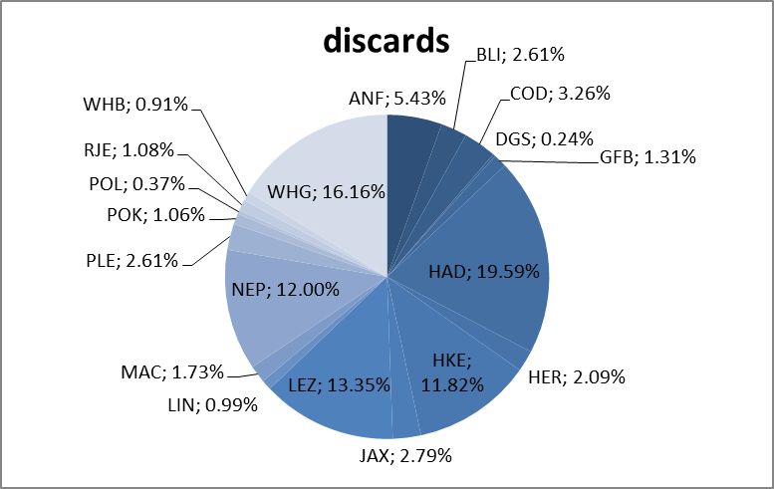

**Figure 2 :** Discard composition of TAC species for TR2 fleet in ICES 6 and 7 b-k (*STECF data base - 2016*)

### Specifying de minimis volume

**Discard volume**

Based on STECF data (year 2016, see annexe I), we established a discard profile in order to estimate maximum volumes of species that would be theoretically discarded under a de minimis as presented in this case. All precautions shall be taken in interpreting and using those estimates as discards can vary significantly from a year to another due to the aleatory specify of fishery activity. Moreover, data used are not always representative. Nevertheless, estimates present hereafter can give a general idea of maximum volume discard estimates.

Those data present an average of catch and discard data for 2013, 2014, 2015 and 2016 (STECF data base).

Based on annex I and II (*STECF* data), mixed demersal vessels in ICES 6 and 7 b-k caught 121 231 tonnes (2016 data) of which 2 115 tonnes were mackerel, boarfish, herring and horse mackerel catches. Thus, a de minimis of 7% would represent theoretically a maximum volume of discards of 148 tonnes (for all bottom trawlers in ICES 6 and 7 b-k).

- Mackerel: 26% of the total of boarfish, mackerel, herring and horse mackerel discards volume

- Horse mackerel: 42% of the total of boarfish, mackerel, herring and horse mackerel discards volume

- Boarfish: 0.01% of the total of boarfish, mackerel, herring and horse mackerel discards volume

- Herring: 32% of the total of boarfish, mackerel, herring and horse mackerel discards volume

**Safeguards**

This de minimis would respond partly in how to implement landing obligation in specific fisheries where it is difficult in a 2019 scenario to implement it. Also this de minimis has its limits and its risks. It is true that the combination of several species can represent a high volume of possible discards. Nevertheless, it will never be more than 7% of the catches concerned.

As said before, volume and composition of catches can be unpredictable and vary from a year to another. It is also important to emphasize that, because of the mixed character of the fisheries it is highly unlikely that only one species would be discarded. This is all the point of a combined de minimis: giving some flexibility needed for fisherman to face the variability of by-catch stocks abundance.

Nevertheless, in order to limit the risk of discarding only one species and because discard rate can be significantly different from a species to another it is propose to put in place safeguard.

Here after is a proposition of safeguards that need to be evaluated and discussed:

According to the discard profile of the fishery (see annexe II), a margin on 25% shall apply. This margin would allow the flexibility needed to face the variability of catches and discards. On the overall discard volume permitted by this exemption, only the proportion calculated (+25%) could be discarded on the overall discard. In this case, and taking all precaution in using those data, this would allow fishermen to discard (see annexe II):

- Mackerel: a maximum of 33% of the total of boarfish, mackerel, herring and horse mackerel discards volume

- Horse mackerel: a maximum of 54% of the total of boarfish, mackerel, herring and horse mackerel discards volume

- Boarfish: a maximum of 0.2% of the total of boarfish, mackerel, herring and horse mackerel discards volume

- Herring: a maximum of 40% of the total of boarfish, mackerel, herring and horse mackerel discards volume

**Those safeguards should be revised if necessary and according to discard profile that can evolve over the years.**

Only for informative purpose, theoretical volumes of discards are presented in Annex II.

### Reference

Balazuc A., Goffier E., Soulet E., Rochet M.J., Leleu K., 2016. EODE – Expérimentation de l’Obligation de DEbarquement à bord de chalutiers de fond artisans de Manche Est et mer du Nord, et essais de valorisation des captures non désirées sous quotas communautaires, 136 + 53 pp.

Cornou Anne-Sophie, Quinio-Scavinner Marion, Delaunay Damien, Dimeet Joel, Goascoz Nicolas, Dube Benoit, Fauconnet Laurence Rochet Marie-Joelle (2015). Observations à bord des navires de pêche professionnelle. Bilan de l'échantillonnage 2014. <http://archimer.ifremer.fr/doc/00286/39722/38188.pdf>

Cornou Anne-Sophie, Quinio-Scavinner Marion, Delaunay Damien, Dimeet Joel, Goascoz Nicolas, Dube Benoit, Fauconnet Laurence Rochet Marie-Joelle (2016). Observations à bord des navires de pêche professionnelle. Bilan de l'échantillonnage 2015. <http://archimer.ifremer.fr/doc/00353/46441/46185.pdf>

Cornou Anne-Sophie, Quinio-Scavinner Marion, Delaunay Damien, Dimeet Joel, Goascoz Nicolas, Dube Benoit, Fauconnet Laurence Rochet Marie-Joelle (2017). Observations à bord des navires de pêche professionnelle. Bilan de l'échantillonnage 2016. <http://archimer.ifremer.fr/doc/00353/46441/46185.pdf>

ICES 2017a.Horse mackerel (Trachurus trachurus) in Subarea 8 and divisions 2.a, 4.a, 5.b, 6.a, 7.a–c, and 7.e–k (the Northeast Atlantic)

<http://ices.dk/sites/pub/Publication%20Reports/Advice/2017/2017/hom.27.2a4a5b6a7a-ce-k8.pdf>

ICES 2017b. Mackerel (Scomber scombrus) in subareas 1–8 and 14, and in Division 9.a (the Northeast Atlantic and adjacent waters)

<http://www.ices.dk/sites/pub/Publication%20Reports/Advice/2017/2017/mac.27.nea.pdf>

ICES 2017c. Boarfish (Capros aper) in subareas 6–8 (Celtic Seas, English Channel, and Bay of Biscay)

<http://www.ices.dk/sites/pub/Publication%20Reports/Advice/2017/2017/boc.27.6-8.pdf>

NATIONAL OCEAN SERVICE

<https://oceanservice.noaa.gov/facts/pelagic.html>

### Annexes

**ANNEX I - Catch, landing and discard of European demersal fisheries in ICES 6 and 7b-k**

*Source : STECF data*



**Annex II - Specifying de minimis for 2019 of demersal trawl fleet in ICES 6 and 7b-k**

*Annex III – Greater Silver Smelt*

