De minimis proposal for undersized by-catches of haddock in the TR1 demersal trawl fisheries in the Irish Sea, ICES 7a.

Summary of De Minimis

Species | Haddock in the Irish Sea
Fishery | 100mm modified demersal trawl targeting haddock in Irish Sea (VIIa)
% de minimis requested | 2% of the catches of haddock by the fleet using eliminator trawls with 120mm cod ends in the Irish sea.
Fleet involved | 23 NI vessels (in 2018)  xx IE vessels
Catches and discards | Landings of Haddock in 2016 (NI+IE): 729.5t  Discards of haddock in 2016 (NI+IE): 47.4t  (STECF FDI dataset)
Justification | Increasing selectivity is difficult to achieve without resulting in significant economic losses of target fishery
Other comments | A di minimis is only applicable to those vessels willing to increase selectivity. Those vessels not adapting higher selectivity will continue to have unmarketable catches.

Background

In accordance with Article 15 of regulation (EU) No1380/2013 a de minimis exemption is requested for catches of undersized haddock by demersal trawl fisheries using cod ends of 120mm in the Irish Sea, up to a maximum of 2% of the catches of haddock by the identified fleet in the Irish Sea.
This de minimis is sought for the fleet using 120mm cod ends in eliminator trawls on the basis that further selectivity increases are difficult to achieve without economic losses. These fisheries are considered selective but do have low levels of undersized catch. The under sized component will change with the size distribution of the stock which may be significant in some years i.e. for large year classes associated with pulse recruitment events of haddock stocks.
Further increases in selectivity would remove most if not all of the undersized component but with an increasing loss of the smaller but marketable catch. A de minimis exemption is sought to support the move to a 120mm codend providing an incentive to improve selectivity while allowing individual fishermen to make a business decision on the best use of their quota.
Improving haddock fisheries are expected to result in additional effort in 2018 and onwards.
Catch and Discard Data
In 2016 STECF data shows total catches of haddock in VIIa by TR1 vessels were 737 tonnes with landings of 692 tonnes and discards of 46 tonnes. This gives a discard rate of 6%.
Total Irish catches in 2016 were recorded as 137 tonnes (103 tonnes landings and 34 tonnes discards). This is all fish below MCRS.
Discard analysis from the Northern Ireland fleet is undertaken by AFBI and covers catches by TR 1 vessels targeting haddock and hake. Landings for the Northern Ireland fleet were 600 tonnes with 588 tonnes of landings and 12 tonnes of discards of which 29% of discards are fish below MCRS. Based on this data a summary of the proposed de minimis exemptions is shown in Table 1.
Country | Exemption applied for (species, area, gear type) | Species as a bycatch or target | Number of vessels subject to LO | Landings (by LO subject Vessels) | Estimated Discards | Estimated Catch | Discard Rate | Estimated de minimis volumes (2%)
UK | Haddock  VIIa  TR1 | Both | 23 | 588 | 12 | 599 | 2% | 12
IE | Haddock  VIIa  TR1 | Both | 17 | 103 | 34 | 137 | 25% | 3

Description of the species and fisheries
Haddock (ICES Area 7a): ICES report that this stock is currently at the highest observed SSB level, and while recruitment is currently above the long term mean it is subject to high variation. ICES currently identify catch and discard rates as below. The stock is within MSY requirements. In UK fisheries the stock is mainly caught in both the directed nephrops fishery and in targeted whitefish fisheries.
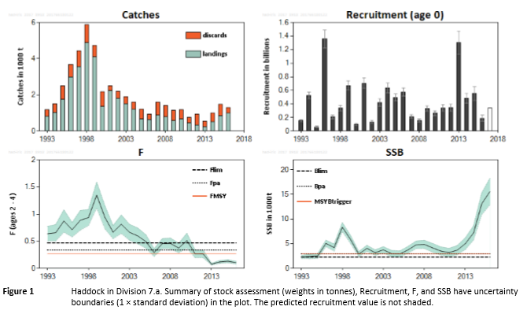

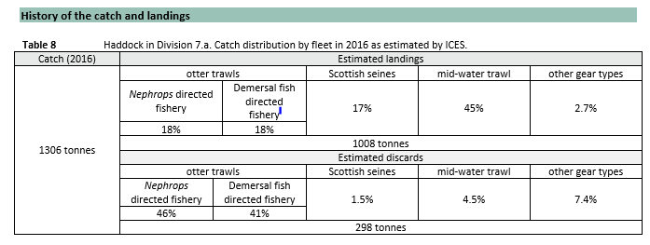
(ICES advice. Haddock 7a, Irish sea- published 30 June 2017)

Current regulations

Northern Ireland continues to operate a number of cod conservation measures in the Irish Sea to protect the recovering cod stock, maintaining a seasonal closure and requiring that all fishing activity (by TR1 and TR2 gears) uses gears demonstrated to have low mortality on cod stocks. Targeted fisheries for haddock are only permitted on the basis that they can demonstrate low impact on cod stocks. Vessels must have prior authorisation to use TR1 gears.
Spatial and temporal restrictions apply to TR1 gears; the seasonal directed hake fishery is permitted only north of 54.3000ºN. For TR1 gears south of 54.3300ºN there is no directed whitefish fishery permitted between 14th February and 30th April. A dedicated scientific observer scheme is in operation for the directed haddock fishery to demonstrate low mortality on cod stocks (annex XIIIa). The regulated gear for the haddock fishery is the ‘eliminator’ trawl, this regulated gear has a cod end of 100mm. Details in Appendix.
Irish vessels use 100mm codend at present with no additional selectivity measures.

Selectivity options - UK
The eliminator trawl was adopted for the Irish Sea following its adoption and assessment for the Scottish Cod Conservation Credits Scheme. The trawl design is adopted from a Canadian design which has received positive assessments for reducing catches of cod while maintaining catches of haddock.
STECF have previously assessed a number of selectivity changes for demersal gears and the impact on haddock and whiting catches for the Irish Sea and Celtic sea. For example, STECF (Plen-11-03) noted that there are a number of cod end configurations that could be introduced to reduce cod catches and mitigate discarding of haddock (and whiting). Ultimately the choice is dependant on the target of the conservation measure and the stock composition likely to be encountered. In general it is expected that a move from 100mm to 120 mm will result in an increase on l50 by between 6 and 7cm. (Fryer 2014). This is expected to result in the removal of all under sized haddock catches with the possible loss of up to 10% of haddock catch. (AFBI communication). This loss would be in mitigated in part by the relatively low value of the lost catch.

Selectivity options – Ireland
Ireland has tested a demersal trawl with a raised fishing line above the seabed to sort cod from species such as haddock, whiting, hake and saithe. Cod and other groundfish species such as anglerfish, skates and rays and megrim pass under the trawl and escape. Research in Denmark has demonstrated reductions in cod catches of 55% during day time and 82% at night time by raising the fishing line by ~ 60 cm from the seabed. Further trials in Ireland resulted in a reduction of cod catches by 39% by weight in the raised fishing line compared with a standard fishing line. Whiting and haddock catches increased by 87% and 37% by weight respectively in the raised fishing line. This led to an increase in total catch value of 14% offsetting loss in catches of commercial species such as flatfish and monkfish in the modified gear. Catches of skates and rays were also reduced by 80% by weight in the raised fishing line. This type of selective gear would seem to have potential in fisheries targeting haddock and whiting, particularly in situations where vessels have limited access to cod quota. However, this gear is currently not used in the Irish Sea fishery and it has only been tested in the Celtic sea mixed gadoid fishery. It requires further testing in the Irish Sea before it is seen as a viable option.

De Minimis requested
An example of the de minimis requested is below, using 2016 figures.
TR1 | Discard (t) | Landing (t) | Discard Rate % | % Below MCRS | Total Catch (t) | Percentage requested | De Minimis Volume (t) | Volume of u/s discards (t)
HAD –UK | 11.7 | 587.5 | 1.9 | 29.4 | 599.2 | 2% | 11.9 | 3.43
HAD – IE | 34 | 103 | 25 | 100 | 137 | 2% | 3 | 31

Conclusions
- Current levels of discards are low; increasing selectivity will remove most of the under sized catch.
- Vessels adopting greater selectivity will have little incidence of under sized catches, but with a loss of some marketable catch. Vessels will avoid smaller fish, and will be able to maximise the use of quota with larger grade catches. This will be a business decision of the vessel operator-interest in using this de minimis will depend on the current stock dynamics and individual situation of the vessel.
- Coupling de minimis exemptions with improved selectivity gives fishermen a choice depending on their individual situation and fishing patterns.
- De minimis is only requested for under sized fish- no discarding of marketable catch is permitted.

Next steps and future research.

- The scientific observer programme will continue to monitor the catches by these TR1 fleets and these catches will be assessed against the wider fleet.
- The percentage of undersized catch can be expected to vary each year depending on recruitment. The de minimis prevision may need to be varied in future years should there be high levels of small fish expected.

References.

Fryer (2014). A meta-analysis of haddock size-selection data, Robert John Fryer, Finbarr Gerard O’Neill & Alexius Edridge. Fish and fisheries, December 2014
Matthew McHugh, Daragh Browne, Martin Oliver, Peter Tyndall, Cóilín Minto and Ronán Cosgrove (2017). Raising the fishing line to reduce cod catches in demersal trawls targeting fish species. BIM Fisheries Conservation Report, May 2017. 9pp.
Prellezo R., Carmona I., García D., Arregi L., Ruiz J., Onandia I. 2017. Bioeconomic assessment of a change in fishing gear selectivity: the case of a single-species fleet affected by the landing obligation. Sci. Mar. 81(3): 371-380. doi: http://dx.doi.org/10.3989/scimar.04597.18A

Appendix

Specification of Eliminator Trawl for TR1 gear currently in use by NI vessels.

An Eliminator Trawl must include all the following as a minimum specification:

- All top sheet wing netting sections to be made of mesh netting of at least 600mm mesh size;

- All lower sheet wing netting sections to be made of mesh netting of at least 600mm mesh size;

- The belly panel must be made of mesh netting of at least 600mm mesh size. It must extend across the full width of the trawl, be attached directly to the fishing line and extend towards the rear of the net for at least 7.5m (stretched length); and,

- All top sheet netting directly above and forward of the belly panel must be made of mesh netting of at least 600mm mesh size.

- The cod end must be constructed from diamond mesh.

http://assets.worldwildlife.org/publications/668/files/original/2007_winners.pdf?1392737742

