**ACRUNET Statement on Science and the Future Direction of Management of Brown Crab Fisheries.**

**Statement:**

1. **Background**
   1. Since 2012, the brown crab catching and processing sector in the United Kingdom, Republic of Ireland and France has collaborated extensively with other industry, public bodies and research institutions covering the main supply chains for product to the French, Spanish and Portuguese markets through the Atlantic brown crab resource users network (ACRUNET) Interreg project.
   2. This has allowed important advances to be achieved towards improving the status of the industry through activities to support product development, markets and promotion, transportation, husbandry and the science underpinning the fisheries.
   3. Although significant progress has been made to advance the industry, there is common agreement among the fishing industry partners of ACRUNET that the current fisheries management arrangements that govern the exploitation of the fisheries are inadequate, and without reform present a critical threat to the industry’s future.
   4. Scientific advice presented during the project has underlined that assessments of brown crab stocks remain data poor. However there is enough evidence available to guide policy makers and fisheries managers to conclude that the likelihood is that:

* although there are exceptions, in general, the brown crab fisheries are fully exploited, and;
* significant additional fishing effort could undermine the long-term sustainability and yield from these fisheries.
  1. Furthermore, there is recognition that industry as a whole require the assurance of having in place proactively, well managed fisheries in order reduce business risk, attract investment and secure market endorsement for their product.
  2. Domestic management of the French fisheries is already considered to be robust enough to react to changes in stock advice, but proactive systems of management in the United Kingdom and the Republic of Ireland predominantly remain absent, and attempts to put in place incremental management adjustments have stalled over a long period of time.
  3. At the same time, under the implementation of the Marine Strategy Framework Directive, the fisheries are coming under closer scrutiny, with the potential that the assessment of their stock status will be accounted for when determining Good Environmental Status.

1. **Towards a Management Strategy For the Brown Crab Fisheries**
   1. In light of the above, we therefore consider that taking prudent and proportionate, precautionary action to establish proactive management arrangements is integral to the maintenance of industry vitality and long-term sustainability, and would be in accordance with broader marine policy objectives already in place at the European level.
   2. The industry partners of ACRUNET consider therefore that a strategy with a clear timeframe of outcomes should be adopted by the member states as a matter of high priority to deliver management objectives aimed at:
2. Strengthening of the evidence base that enable assessments to account for the full spatial coverage of the fisheries and therefore better underpin management. The first step would be the development of evidence strategy that among other things helps to facilitate partnerships between scientific institutions and industry so that industry is enabled to contribute greater levels of data to the assessment process.

1. Preventing any further significant growth in fleet capacity, particularly among the high catching component of the fleet in the UK and ROI, through appropriate licensing arrangements that address the latent capacity that currently exists.
2. Working to develop responsive management measures to be applied in the event that stock status significantly deteriorates, or in order to transition sub-optimal fisheries towards optimal yields over an appropriate period of time.

1. Establishing responsive measures to be applied as part of multi-annual management plans for the fisheries, taken forward by managers in close collaboration with industry and with scientific input.
2. Plans should take account of the diversity of the fleets prosecuting the fisheries and, including those measures already in force, be consistent with effective management of both inshore and offshore fisheries, recognising the differences in management jurisdiction between inshore and offshore regimes.
3. In addition, the UK and RoI industry partners of ACRUNET agree that current technical minimum conservation reference size (MCRS) measures should be increased in many areas.
4. Signatories:



**Killybegs Fishermen’s Organisation Ltd**

Signed: Date: 12th August 2015

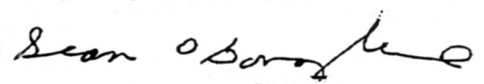

__________________

Sean O’Donoghue, CEO



**The Shellfish Association of Great Britain**

Signed: Date: 12th August 2015

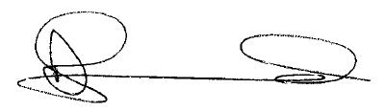

---------------------------------

David L Jarrad, CEO

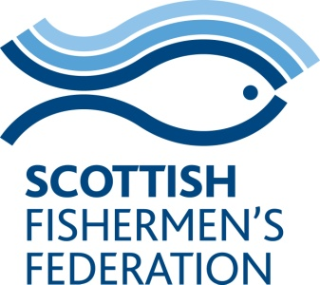

**Scottish Fishermen’s Federation**

Signed Date: 1st September 2015

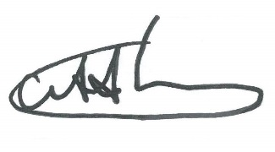

------------------------

Bertie Armstrong, CEO

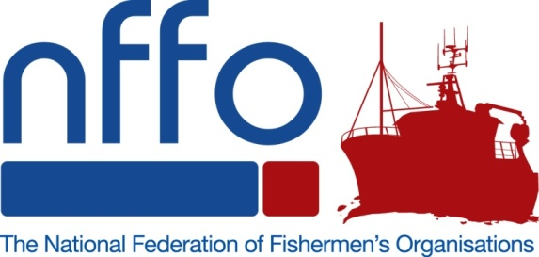

**National Federation of Fishermen’s Organisations**

Signed Date: 3rd September 2015

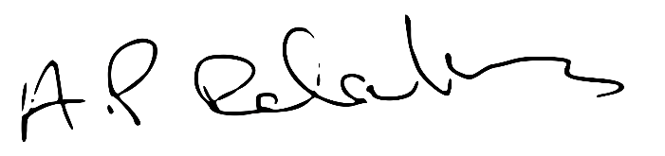

------------------------

Anthony Delahunty, Chairman