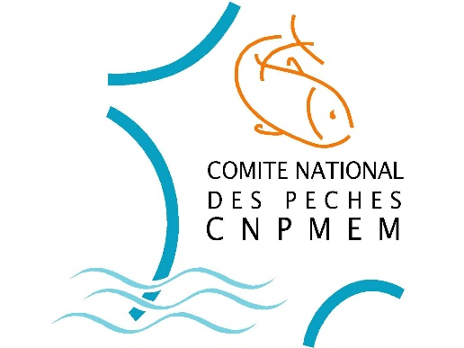
Position of the CNPMEM in response to the letter from the European Commission concerning the management of sea bass fisheries in the Northern area in 2019
Version of August 7th, 2018

Premise
The CNPMEM considers that landing obligation should not apply to sea bass in the Northern area (ICES divisions 4.b-c, 7.a and 7.d-h), given that this stock is subject to a fishing ban to which certain exemptions are added, as specified in article 9 of the Regulation on Fishing opportunities for 2018 (R(EU) n°2018/120). In addition, this fishery is not subject to TAC.

Adaptation of management measures for 2019
Regarding the ICES advice for 2019 and the new perception of the status of the stock, the CNPMEM reckons that the adaptation of management measures of article 9 can be considered.
The position of the French industry concerns professional fisheries and is based upon:
- The known reference points, which are the management measures and production in 2017: the cumulation of production (984 tonnes) and discards registered in 2017 is of the same volume as the removal possibilities recommended by ICES for 2019. Therefore, the CNPMEM proposes that discussions for the 2017 management measures be based on the management measures applied in 2017, in particular regarding catch levels per metier (retention of F₂₀₁₉ at the level of F₂₀₁₇);
- The principle of a reduction in socio-economic waste represented by discards of sea bass of legal size for the benefit of landings, for trawl netting and Danish seine metiers. Indeed, quantities discarded during the first five months of the year 2018 represent more than twice the quantities landed over the same period. More than 98% of discards declared in 2017 by French vessels related to trawl net and Danish seine fishing. For these metiers, where fishing opportunities are limited to unavoidable catch, this implies the following:
  - Lifting the ban on catches in February and March, the unavoidable nature of catches does not cease during the year, in particular during this period, which shows the highest volumes of discards (126 t in February-March 2018 in France). The lack of discard declarations by the set net metiers does not allow one to consider such an evolution for these metiers;
  - Maintaining an individual landing restriction set according to a percentage of total catch, to ban any targeted fishing practices, expressed not by day but by tide, better adapted to these metiers and easier to monitor;
  - Setting, in addition, an annualised individual landing restriction bringing more flexibility and consistency considering the diversity of situations in the area.
- Maintaining the annualised individual landing restrictions and overall restrictions of capacity and effort for set net and hook and line metiers that are currently accepted.
The strict application of these principles results in proposals for measures and individual quantitative landing restrictions by metier for 2019, set out in the following table:

 | 2017 Measures | 2018 Measures | 2019 Proposals
Hook and line metiers | February-March ban  10 t/year  Capacity ceiling | February-March ban  5 t/year  Capacity ceiling | February-March ban  10 t/year (or 6-7 t/year)  Capacity ceiling
Set net | 250 Kg/month  Capacity ceiling | February-March ban  1.2 t/year  Capacity ceiling | February-March ban  3 t/year (i.e. 0.25 t × 12)  Capacity ceiling
Trawl net and Danish seine | 3 % total catch/day  400 Kg/month | February-March ban  1% total catch/day  100 Kg/month (trawl net)  180 Kg/month (seine) | 3% total catch/tide  4.8 t/year (i.e. 0.4 t × 12)
Professional fishing from the shore | Total ban | Total ban | Total ban  or exemption (tbd)
ICES Advice (professional + recreational) | Total ban | 880 tonnes | 1789 tonnes

The primary objective of the French industry is to reduce discards of sea bass by trawl net and Danish seine metiers. According to the CNPMEM, the 2019 proposal for these metiers represents an acceptable compromise, given the reality of discards in France (368 tonnes in 2017).
Insofar as the number of French vessels that landed more than 7 tonnes of sea bass caught by line and hook metiers in 2017 was very low, the French industry is considering the possibility of only supporting a reduced increase of the individual catch restriction to 6 or 7 t/year for these metiers in return for an opening of fishing opportunities (at least equivalent to those applied to recreational fishing) for professional shore fishermen. However, this opening should not weaken the primary objective aimed at reducing discards. These adjustments, which appear in blue in the table, are still being discussed within the CNPMEM.

