NWWAC MEETINGS
GHENT
3rd July 2018; 09:00 – 18:00
and
4th July 2018; 09:00 – 15:30
Meeting Room - 21.04 Jacob Van Artevelde

Venue - Virginie Loveling Gebouw (VAC)

Koningin Maria Hendrikaplein 70,

9000 Ghent
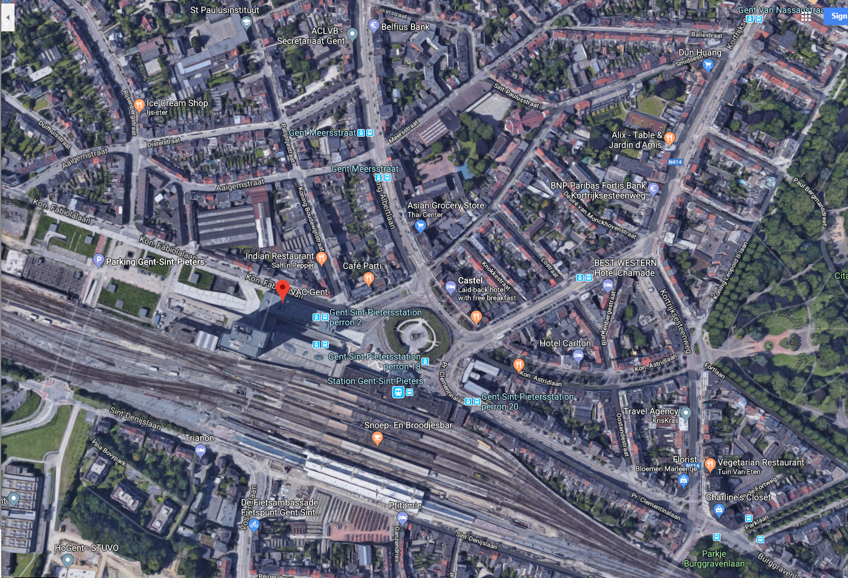
Ghent Train Station (Sint-Pieters)
Virginie Loveling Gebouw (VAC)

Recommended hotels within walking distance:

Hotel Gent Sint Pieters ****
Koninigen Maria Hendrikplein, 1, B-9000, Ghent
Tel: 0032 9 222 6065
E-mail: nhgentsintpieters@nh-hotels.com

Hotel Chamade ***
Koningen Elisabethlaan, 3, B-9000, Ghent
Tel: 0032 9 220 1515
E-mail: info@chamade.be

Hotel Castel ***
Koningen Maria Hendrikplein, 1, B-9000, Ghent
Tel: 0032 9 242 0292
E-mail: info@hotelcastel.be

Hotel Carlton ***
Koningen Astridlaan, 138, B-9000, Ghent
Tel: 0032 9 222 8836
E-mail: info@carltongent.be

