**High Survival Exemption for fish caught in pots, traps and creels in North Western Waters**

This note presents the information which was provided to the North Sea group in support of a high survival exemption for fish caught in pots, traps and creels.

The UK believes that there is sufficient commonality between the fishing operations described in the North Sea and the fishing operations in the North Western Waters to use the evidence provided in the North Sea to support a high survival exemption in the North Western Waters.

The information provided to this Group is attached at the following Annexes:

* The discard survival of fish in pots, traps and creels (Annex A);
* A pilot study on fish mortality inflicted during the release phase (avian predation) (Annex B); and
* A description of Scottish fisheries with pots, traps and creels in the waters around Scotland (Annex C).

Annex A – Evidence for High Survival of Fish Caught in Pots, Traps and Creels

Pots, traps and creels attract, collect and hold catches alive until hauling. The gears operate by trapping a catch, alive, inside a static netting structure instead of killing a fish through entanglement or hooking like other passive fishing gears.

In 2014 Sweden proposed a high survival exemption for cod and salmon caught in pots traps and creel in the Baltic Sea.

The evidence for the exemption of Baltic cod in pots and traps were data from two studies in Sweden and Germany. The Swedish study (Peter Ljungberg SLU-Aqua pers. comm) indicated that in pots were soak time accidently were prolonged (up to 47 days), fished at 20-50 m depth, the numbers of dead cods observed at hauling were very low (<0.1% of more than 2500 caught cod). The German study used trap caught cod (750 individuals sized between 15-35 cm), fished at 3-5 m depth and also transported in tanks for 3 hours, in growth experiments and observed no mortalities (experiment but not mortality presented in Stötera et al 2015). The observation period was not specified in this study.

In addition, some other information is available on discard survival from pots. These studies are mainly focused on cod. Pots are believed to be benign gears since fish in catches are often alive and with high flesh quality (Rotabakk et al., 2011; Suuronen et al., 2012; Thomsen et al., 2010). Nøstvik and Pedersen (1999) found that more than 90% of the cod larger than 20 cm and captured by fish pots, fyke net and hand line were viable and fit for tagging. Weltersbach and Strehlow (2013) used pot caught cod as controls in an experiment studying mortality of angled cod and reported mortalities of the potted cod of 0-25%. The variable mortality between samples was reported to be temperature related. Recently, Humborstad et al. (2016) reported on experiments on mortality of pot- and longline caught cod in Norway. They found an average mortality of 9% after up to 14 days for the fraction of the pot-caught cod that was able to submerge after capture (60% of the caught cod). For cod that was not able to submerge mortality was much higher if not dealt with (79% mortality). The high prevalence of cod with compromised buoyancy (floaters) in the study was, as discussed in Humborstad et al. (2016), most likely due to the relatively large fishing depths 114-184m in combination with haul-back speed. Earlier studies made in shallower waters reported lower percentages of floaters: 22% at 50-130 m (Løkkeborg et al. 2014), and 2% at <50 m (Ferther et al. 2015).

Depth is thus an important factor that affects post-capture survivability. In the Scottish coastal zone, the coastline varies between deep and narrow sheltered sea lochs on the west coast, shallow bays and estuaries. Average water depths vary, but are generally between 50 and 200 m for the inshore zone, the waters being shallower around the south west of Scotland, and typically between 100 and 150 m to the west of the Hebrides and off the north coast.

When hauled from depth, the swimbladder of physoclist species (i.e. most roundfish species that lack a connection between the gas bladder and the digestive tract) expands and the fish may suffer barotraumas like bloated eyes (exophthalmia), distended stomach/oesophagus and loss of equilibrium/balance (see Humborstad et al. 2016 and references therein). Cod have been shown to have a mechanism for dealing with swimbladder rupture, gas release and healing (Humborstad and Mangor-Jensen 2013). It is therefore important to minimize the proportion of floaters in order to allow released fish to dive quickly after release and thereby reduce risks of avian predation.

In its response, STECF (2014c) considered it reasonable to assume that mortality in the catch phase for these gears is low, but suggested that more work was needed to confirm whether this assumption was valid. It noted that in addition to potential mortality caused during the catching phase, the survival of discarded fish would also depend on handling and release practises after sorting on-board. STECF (2014c) therefore noted that more research on such practises would be informative.

Regardless, the Baltic proposal was accepted and is now in the current Baltic discard plan [(Commission Delegated Regulation (EU) 1396/2014)](http://eur-lex.europa.eu/legal-content/EN/TXT/PDF/?uri=CELEX:32014R1396&from=EN).

In the North Sea, Sweden tabled its proposal for a high survival exemption in 2017 on the same evidence. In its consideration of the request [STECF](https://stecf.jrc.ec.europa.eu/c/document_library/get_file?uuid=00a2cc34-45ac-4034-ad8f-a84553ea8462&groupId=43805) (p.30) noted that though:

“No direct evidence is presented on the survival rates of the discarded species in the proposed fisheries … it is reasonable to infer that, at the point of release, and assuming environmental and technical operations are comparable, the likelihood of survival is high. The risk of substantial avian predation of discarded fish needs to be considered in such an exemption.”

As a result the exemption was included in Article 6 of [Commission Delegated Regulation (EU) 2018/45](http://eur-lex.europa.eu/legal-content/EN/TXT/PDF/?uri=CELEX:32018R0045&from=EN).

Annex B - Pilot Study of Avian Predation of Released Fish By-Catches

STECF (2014c), and most other scientific studies, assume it is reasonable to believe that the mortality in the catch phase for these gears is low but that more work on how handling and release practises after sorting on-board affects discard mortality. The pilot study was a response to that call and therefore aimed at looking into the immediate mortality caused by handling and release of unwanted fish by-catches.

*Methods*

A trained scientific observer recorded the fate of all discarded fish during five *Nephrops* creel trips in the Skagerrak between October 2016 and April 2017. Fish was discarded by the fishers as in normal commercial practise and the observer recorded species, condition (vivid, tired or motionless/dead) and fate (dived down, taken by bird or other/unclear fate).

A total of 421 individual fish of 16 species was observed. The fate of 7 most common species is presented in Table 1. In total 56% of all discarded fish was taken by seabirds. 47% of all released cod was taken by seabirds (up to 83% on the trip with the highest amount of discarded cod. Avian mortality varied greatly between trips, which is most likely an effect of different amounts of discarded by-catches, different amounts of attending seabirds around the vessel and different release mechanisms/behaviours on different vessels. The condition of released fish did not seem to affect the fate. Most released fish taken by birds was caught immediately upon hitting the sea surface (or even in the air before landing at the sea surface). The seabird species observed to feed on discarded fish during the observed trips was mainly Great black-backed gulls and Herring gulls but also Lesser black-backed gulls and Mew gulls were observed.

Table 1. Summary of the fate of discarded fish as observed on five *Nephrops* creel trips



Thus, although the fishing method itself is benign to fish survivability other parts of the fishing process may be more important for discard survivability. Catch handling on a *Nephrops* creel vessel means that the catch in each creel along the string is sorted immediately upon arrival on deck. The creel is then rebaited and stacked on deck. The quick handling process means that returned discards are only exposed to air for around 10-20 seconds, which should mean a minimal stress compared to catch handling in most other fisheries. The pilot study thus indicate that although the catch and handling phases in pot/creel fisheries are likely inflict low mortality on fish catches, the subsequent release phase when returned fish is exposed to avian predators is the key in order to minimise discard mortality.

Alternative release mechanisms for discards already exist in the creel fishery. A few Swedish vessels have voluntarily mounted tubes at the sorting table (Fig. 1a). The tube either exits through the hull or below the surface on the outside of the hull (Fig 1b). As these kinds of arrangements make it much more difficult for seabirds to catch discarded fish, they are likely to greatly improve survival chances of discarded fish and should be considered as a mandatory requirement if a survival exemption is to be granted for this fishery.

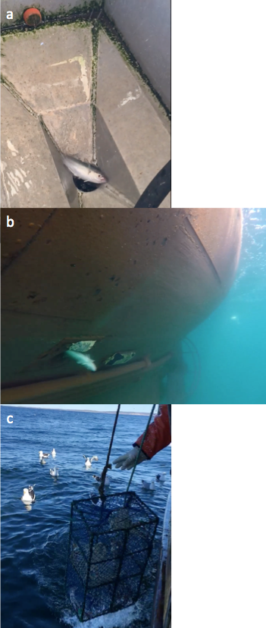

Figure 1.

(a) Example of a release tube arrangement aboard a *Nephrops* creel vessel with the entrance of the release tube in a sink at the sorting table with a small saithe;

(b) A discarded cod swims out through the tube entrance under water;

(c) Gulls waiting for food.

Annex C – Description of Scottish Pot, Trap and Creel fisheries

The majority of creel effort in Scotland's inshore waters can be broken down into three key fisheries; the west coast *Nephrops* creel fishery; the west coast crab and lobster creel fishery; the east coast crab and lobster creel fishery; the north coast crab and lobster creel fishery; and the island crab and lobster creel fishery which occurs around Orkney and the Outer Hebrides.

Scottish Nephrops (Nephrops norvegicus), which developed as a commercial fishery from the 1960s, is now Scotland's second most valuable species with over 16,000 tonnes landed in 2016, worth £75 million. Scotland is allocated the majority of Europe's total allowable catch (TAC) for this species and takes over one third of Nephrops landings worldwide. Nephrops are caught by trawlers operating in both the North Sea and West of Scotland waters, but those caught by creels and sold to the live market are significant on the west coast of Scotland.

Landings have remained relatively stable from static gear vessels at around 1,600 tonnes, whilst mobile gear landings have fluctuating between 10,000 and 13,000 tonnes between 2008 to 2015. The value of the fishery has also remained relatively stable over the same period for static gear vessels at around £14 million whilst mobile gear values have ranging from £23 million to £32 million with a spike in 2012 of £37 million.

Crab and lobster are important fisheries in Scotland Landings of brown crab into Scotland totalled 11,000 tonnes in 2015 with a value of £14 million (Fig. 8). The majority of brown crab comes from West of Scotland waters (54%) the remaining from the North Sea (46%). Catch rates have remained relatively stable since 2011 after an increase in tonnage landed. The value of these landings has increased from around £11 million in 2008 to £14 million in 2015 (Fig. 8). This fishery is long established and traditionally most brown crab was caught using creels in inshore waters but from the mid 1980s technological advances allowed the fishery to expand to offshore fishing grounds. Inshore grounds now accounts for around two thirds of brown crab landings and the remaining is caught offshore[[3]](http://www.gov.scot/Publications/2017/08/1797/11).

The European lobster is an important fishery to Scotland worth around £11 million in 2015 from just over 1,000 tonnes of landed lobster (Fig. 9). The majority of lobster was taken from the North Sea (71%) and the remaining from west of Scotland waters (29%) in 2015. Lobster landings have remained relatively stable since 2008, with the exception of a small dip in 2013, fluctuating between 1,000 and 1,200 tonnes per year. Prices have also fluctuated between £10 million and £13 million over the same period (Fig. 9).

Velvet crab, traditionally considered a 'pest' species, is now a seasonal fishery which became financially viable in Scotland because of stock collapse in the Spanish fishery in the early 1980s. Scotland now supports the largest velvet crab fishery in Europe[[4]](http://www.gov.scot/Publications/2017/08/1797/11). In 2015, 1,500 tonnes of velvet crab were landed into Scotland with a value of £3.7 million. Landed weight in this fishery has been on the decline year on year from 2,700 tonnes in 2008 (Fig. 10). This is also reflected in the value of the fishery although prices per tonne have held or increased over this period.

To gather data on the interactions of *Nephrops* creels with other marine species, fishers were asked what other species they commonly encountered when hauling their creels. Squat lobster was the species most cited by fishers*,* followed by brown crab, octopus and cod (Fig. 18). Most fishers reported an increase in cod/codling (juvenile cod) over recent years compared to the past. Others discussed the increase in octopus which predates on *Nephrops*. A total of 27 species were cited as interacting with *Nephrops* gears.

**Figure 18: Most commonly encountered species in *Nephrops* gear cited by interviewees**

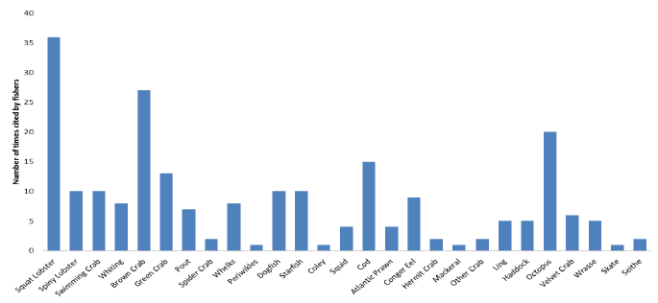

**Figure 19: Most commonly encountered species in West of Scotland crab and lobster gear cited by interviewees**

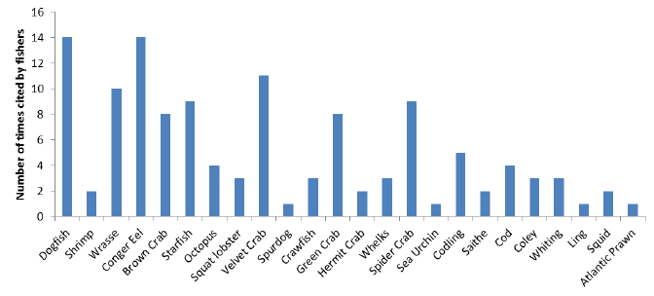

**Figure 20: Most commonly encountered species in east coast crab and lobster gear cited by interviewees**

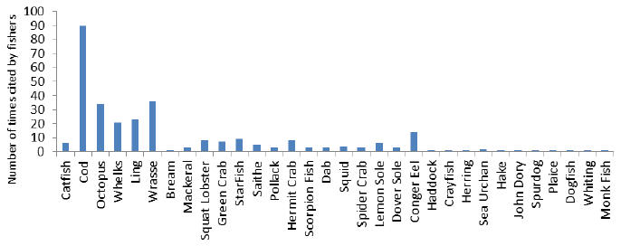

In the West of Scotland crab and lobster creels, 24 species where cited by fishers as encountered (Fig. 19). The two most common species were dogfish and conger eel, followed by wrasse, velvet crab, spider crab and green crab. Velvet and brown crab were included on these by-catch lists as they were undersized and therefore discarded.

On the east coast, 32 species where cited by fishers as encountered in crab and lobster creels (Fig. 20). The most common species was cod listed 90 times, followed by wrasse, octopus, ling and whelk (20-30 times each). A much wider range of other species were listed as interacting with east coast creels compared to the west coast. This could be due to higher survey sampling on the east coast, data collection methods (all species encountered rather than most common) or higher retention rates in parlour creels, which dominate on the east coast as opposed to D-shape prawn creels which dominate on the west coast.

Access and deployment rates vary between these fisheries with vessels accessing up to a maximum of 3,000 (deployment 2,500) creels in the west coast *Nephrops* fishery compared with 1,200 (deployed 900) creels in the west coast crab and lobster fishery and 2,300 (accessed and deployed) in the east coast crab and lobster fishery. The average number for creels accessed and deployed by vessels was much lower than the maximum figures which was on average 1,009 (926 deployed) in the west coast *Nephrops* fishery, compared to a 359 creels (294 deployed) in the west coast crab and lobster fishery, and 542 (455 deployed) in the east coast crab and lobster fishery.

The amount of creels deployed are best related to length of vessel or, more favoured by fishers, number of crew. When broken down by crews the number of *Nephrops* creels deployed has a somewhat linear increase (+~600 creels per crew member) which is also the case in the east coast crab and lobster fishers (+~350 creels per crew member). These increases are higher than the reported average daily hauling rates of 400 creels per crew member in the *Nephrops* fishery and 200 creels per crew member in the crab and lobster fisheries.

Creel numbers deployed do not appear to vary significantly between seasons in the west coast *Nephrops* fishery, but they do vary substantially in the east coast crab and lobster fishery with an increase of almost a third from the lowest deployment levels in February up to peak deployment levels in August. Hauling frequencies also varied between season in all fisheries with most fishers hauling every 2 days during the summer or good weather periods which extended up to a week or longer in winter or poor weather periods.

.

Table 3. Summary of information for the proposed survival exemption for pots, traps and creels in area 6a

|  |  |  |  |  |  |  |  |  |
| --- | --- | --- | --- | --- | --- | --- | --- | --- |
| **Country** | **Exemption applied for (species, area, gear type)** | **Species as bycatch or target** | **Number of vessels subject to the landing obligation** | **Landings (by landing obligation subject vessels)** | **Estimated Discards** | **Estimated Catch** | **Discard Rate** | **Estimated discard survival rate from provided studies** |
| Scotland | All fish species in area 6a caught in pots,traps and creels | bycatch | 1,400 | 71,265t in total; of which  15,977t of nephrops; and  3,739t of other species | n/a | n/a | n/a | >90% |

These figures are for NS and NWW combined.

References

Adey, J.M. 2007. Aspects of the sustainability of creel fishing for Norway lobster, *Nephrops norvegicus* (L. ), on the west coast of Scotland. PdD thesis. 488pp. http://theses.gla.ac.uk/524/

Broadhurst, M.K., 2000. Modifications to reduce by-catch in prawn trawls: a review and framework for development. Rev. Fish. Biol. Fish. 10 (1), 27–60.

Catchpole, T. L., Revill, A. S., and Dunlin, G. 2006. An assessment of the Swedish grid and square mesh cod-end in the English (Farn Deeps) *Nephrops* fishery. Fisheries Research, 81: 118-125.

Catchpole, T. L., Revill, A. S. 2007. Gear technology in Norway lobster trawl fisheries. Reviews in Fish biology and Fisheries, 18: 17-31.

He, P and V. Balzano 2012a. The effect of grid spacing on size selectivity of shrimps in a pink shrimp trawl with a dual-grid size sorting system. Fisheries research 121-100-107.

He, P and V. Balzano 2012b. Improving size selectivity of shrimp trawls in the gulf of maine with a modified dual–grid size sorting system. Fish.Res.121-122 81-87

Isaksen, B., Valdemarsen, J. W., Larsen, R. B., and Karlsen, L. 1992. Reduction of fish by-catch in shrimp trawl using a rigid separator grid in the aft belly. Fisheries Research, 13: 335-352.

Jansson, T. 2008. Discards in the Swedish creel fishery for *Nephrops norvegicus*.

MSc. Contribution No. 146, University of Gothenburg. Available at: <http://www.marecol.gu.se/digitalAssets/1192/1192393_discards_creel_fishery_tj.pdf>

Ferther, K., Weltersbach, M. S., Humbortstad, O.-B., Fjelldal, P.G., Sambraus, F., Strehlow, H.V., Vølstad, J.H. (2015). Dice to survive: effects of capture depth on barotrauma and post-release survival of Atlantic cod (Gadus morhus) in recreational fisheries. ICES J. Mar. Sci. 72(8), 2467-2481.

Hickey, W.M ., Brothers, g., Boulos D.L. 1993. Bycatch reduction in the Northern shrimp fishery. Can Tech.Rep.Fish.Aquat.Sci.1964.41

Hornborg, S., M. Ulmestrand, M. Sköld, P. Jonsson, D. Valentinsson, O. R. Eigaard, J. Feekings, J. R. Nielsen, F. Bastardie and J. Lövgren. (2016). New policies may call for new approaches: the case of the Swedish Norway Lobster (*Nephrops norvegicus*) fisheries in the Kattegat and Skagerrak". ICES Journal of Marine Science. 74(1): 134-145. [doi.org/10.1093/icesjms/fsw153](https://doi.org/10.1093/icesjms/fsw153)

Humborstad, O.-B., Mangor-Jensen, A., 2013. Buoyancy adjustment afterswimbladder puncture in cod Gadus morhua: an experimental study on theeffect of rapid

Humborstad, O.-B., Breen, M., Davis, M.W., Løkkeborg S., Mangor-Jensen, A., Midling, K.Ø., Olsen, R.E. (2016). Survival and recovery of longline- and pot-caught cod (*Gadus morhua*) for use in capture-based aquaculture (CBA). Fish. Res. 174, 103-108.

Lehman., K., J.W Valdemarsen, and F Riget. 1993. Selectivity in shrimp trawl codends tested in fishery in Greenland. ICES marine science symposia 196:80-85

Løkkeborg, S., Evensen, T., Humborstad, O.B., James, P., Jørgensen, T., Midling, K.,Saltskår, J., 2014. Fiske-og atferdsforsøk av torsk i Troms i september 2013.Rapport fra Havforskningen 5 /2014 (in Norwegian).

Madsen, N and Valentinsson, D (2010). Use of selective devices in trawls to support recovery of the Kattegat cod: a review of experiments and experience. ICES Journal of Marine Science 67(9): 2042-2050.

Nøstvik, F., Pedersen, T., 1999. Catching cod for tagging experiments. Fish. Res. 42,57–66.

Rihan, D.J., Browne, D. and McDonald, D. 2009. Celtic Sea cod – Gear Based Technical Measures to help reduce discarding. ICES CM2009/M:19. 15pp.

Sköld, M., H. Svedäng, D. Valentinsson, P. Jonsson, P. Börjesson, J. Lövgren, H.C. Nilsson, A. Svensson and J. Hjelm (2011). Fiskbestånd och bottenmiljö vid svenska västkusten 2004-2009 – effekter av trålgränsutflyttning och andra fiskeregleringar. Finfo 2011:6. 48pp.

Rotabakk, B.T., Skipnes, D., Akse, L., Birkeland, S., 2011. Quality assessment ofAtlantic cod (Gadus morhua) caught by longlining and trawling at the sametime and location. Fish. Res. 112, 44–51.

SLU 2015. Sekretariatet för selektivt fiske - Rapportering av 2014 års verksamhet: Aktiva redskap. http://www.slu.se/Documents/externwebben/akvatiska-resurser/selektivt%20fiske/Rapport%20fo%cc%88r%202014%20Sekretariatet%20fo%cc%88r%20selektivt%20fiske.pdf

STECF 2014a. Scientific, Technical and Economic Committee for Fisheries (STECF) – Landing Obligations in EU Fisheries - part 3 (STECF-14-06). 2014.

Publications Office of the European Union, Luxembourg, EUR 26610 EN, JRC 89785, 56 pp.

STECF 2014b. Scientific, Technical and Economic Committee for Fisheries (STECF) – Evaluation of Fishing Effort Regimes in European Waters - Part 2 (STECF-14-20). 2014. Publications Office of the European Union, Luxembourg, EUR 27027 EN, JRC 93183, 844 pp.

STECF 2014c. Scientific, Technical and Economic Committee for Fisheries (STECF) – 46th Plenary Meeting Report (PLEN-14-02). 2014. Publications Office of the

European Union, Luxembourg, EUR 26810 EN, JRC 91540, 117 pp.

Stötera, S., Degen-Smyrek, A.K. Krumme, U., Stepputis, D., Limmer, B., Hammer, C. (2015). Evaluation of chemical markers for age validation of western Baltic cod (Gadus morhua) otoliths. Frontiers in Marine Science (Conference paper). DOI:10.3389/conf.FMARS.2015.03.00137.

Suuronen, P., Chopin, F., Glass, C., Løkkeborg, S., Matsushita, Y., Queirolo, D., Rihan,D., 2012. Low impact and fuel efficient fishing-Looking beyond the horizon.Fish. Res. 119–120, 135–146.

Thomsen, B., Humborstad, O.B., Furevik, D.M., 2010. Fish pots: fish behaviour,capture processes, and conservation issues. Behav. Mar. Fishes CaptureProcess. Conserv. Chall., 143–158.

Valdemarsen, J.W 1989. Size selectivity in shrimp trawls. Proc.World Symp. Fish Gear Fish vessel Designs, St.Johns. Nov, 1989 pp39-41.

Valdemarsen, J. W.G. Thorsteinsson, J.Boye, K.Lehman and J.A Jakobsen 1996. Seleksion I reketrål. Tema Nord 1996:520.

Valentinsson, D., and Ulmestrand, M. 2008. Species-selective Norway lobster trawling: Swedish grid experiments. Fisheries Research, 90: 109-117.

Valentinsson, D. (ed) (2016). Sekretariatet för selektiv fiske- Rapportering av 2015-års verksamhet. Aqua reports 2016:8. Institutionen för akvatiska resurser, Sveriges lantbruksuniversitet, Lysekil. 126 pp. ISBN: 978-91-576-9403-4 (electronic version).

Weltersbach, M. S., and Strehlow, H. V. 2013. Dead or alive–estimating

post-release mortality of Atlantic cod in the recreational fishery.

ICES Journal of Marine Science, 70: 864–872.

Ziegler F.S., S. Hornborg, D. Valentinsson, E. Skontorp Hognes, G. Søvik, O.R. Eigaard (2016). "Same stock, different management: quantifying the sustainability of Skagerrak shrimp fisheries from a product perspective". ICES Journal of Marine Science 73(7): 1806-1814. doi:10.1093**/**icesjms**/**fsw035