Short note on the potential to increase survival of discards by technical measures in beam trawls
Polet, H., Van Bogaert, N. and Uhlmann, S. (ILVO, Belgium)

The fate of discards in terms of survival depends on species-speciﬁc tolerances to the cumulative effects of several dominant technical, environmental, and biological factors associated with the particular catching mechanisms (Davis, 2002; Broadhurst et al., 2006). Amongst these factors, catch weight or volume and catch composition are important for the condition of fish in the cod-end. It influences the nature and intensity of injuries and thus the associated mortality.
Catch weight has been demonstrated to have an effect on the survival of discarded target species (Nilsson et al., 2016; Broadhurst et al., 2006). Mandelmann and Farrington (2007) observed that larger catch volumes caused greater mortalities among discarded spiny dogfish (Squalus acanthias). Moreover, the crowding density of the catch prior to release (e.g. during slipping in purse-seines) (Tenningen et al., 2012) can result in lower survival. Depestele et al. (2014) indicated catch weight as one of the determining variables explaining the large variability in survival of discards in beam trawls.
It has also been suggested that the proportion of abrasive objects, such as spiny fish may cause scale loss among teleosts confined in a codend (Pranovi et al., 2001; Broadhurst et al., 2006), stinging jellyfish that cannot be excluded from the catch can potentially cause harm (Uhlmann and Broadhurst, 2013) and crustaceans and debris in codends could increase physical damage (Main and Sangster 1988; Bottari et al. 2003). Bergmann et al. (2001) have pointed out that large heavy catches, especially when the contribution of ‘‘hard’’ material is considerable, increase the probability of injury during the haul itself, as well as the compression upon hauling and whilst on deck. In the case of ‘‘rapido’’ trawl fisheries, Sartor et al. (2006) stated this is particularly true when the gear is deployed on seabeds comprised of hard biogenic structures, often producing considerable amounts of hard material amongst the debris, such as stones and dead shells.
In a survival experiment with flatfish beam trawls, van Beek et al. (1990) stated that it is likely that the variation in composition of the catch contributed to the observed variation in survival of discarded fish. It was assumed that the injuries were mainly caused by the scraping and pressing of the various objects in the cod-end such as starfish, stones, shells, sand and pieces of wood.
In addition, the development of the RAMP (Reflex Action Mortality Predictor) method, based on scoring reflex impairment and injury indices to estimate survival probability of fish, has demonstrated to be a reliable proxy for survival. As such, reducing elements in the catch such as stones and debris are likely to have a positive effect on survival of discarded fish.
Catch size and composition can also affect handling practices and duration, in turn affecting survival.
In conclusion, it is quite likely that employing devices in beam trawls that reduce the capture of stones and debris will reduce mortality of discarded fish, especially if species with spines and abrasive skins can also be excluded (such as dogfish, rays, sea urchins and sea stars). Two technical alterations to beam trawls can be used in the commercial beam trawl fishery in conditions when stones and debris are problematic. One device is the so called flip-up rope rigged on top of the bobbin rope in the net opening (Fig. 1). It is mainly used to avoid the capture of larger stones. A second device is the so called ‘benthic release panel’ (Fig. 2), a square mesh panel inserted in the belly of the trawl, just in front of the cod-end. It is traditionally used to release shells when they are caught in too large quantities. The potential of this technique has been demonstrated by Fonteyne and Polet (2002), Revill and Jennings (2005) and Soetaert et al. (2016).

Figures

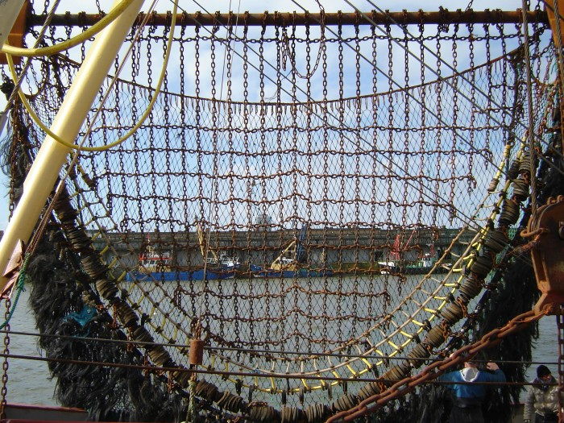
Fig. 1 – Chain matrix beam trawl rigged with a flip-up rope (yellow rope array fixed to the bobbin rope).

The benthos release panel is an escape or release window rigged in the belly of the trawl. The panel is usually fitted just in front of the cod-end but for the case of the Belgian beam trawl, just in front of the Flemish panel.
This panel can be constructed from any netting material with dimensions 1.80m x 1.80m. The meshes are square. Usually these are hand braided, 12 meshes x 12 meshes, and can be constructed from any type of material. The length of the mesh, i.e. the side, is 120mm with a diagonal of 170mm.

1.80 m
1.80 m

Benthos release panel
Flemish
panel

Cod-end
4.5m long

Fig. 2 – Benthos release panel rigged into a beam trawl

References

Bergmann, M. and Moore, P.G., 2001. Survival of decapod crustaceans discarded in the fishery of the Clyde Sea area, Scotland. ICES J. Mar. Sci. 58 (1), 163-171.
Bottari, T., Rinelli, P. and Panebianco, A., 2003. Trawling lesions in some decapod crustaceans: considerations with regard to governmental regulations. Crustaceana 76(8), 927–933.
Broadhurst, M. K., Suuronen, P., and Hulme, A., 2006. Estimating collateral mortality from towed ﬁshing gear. Fish and Fisheries, 7: 180–218.
Berghahn, R., Waltemath, M. and Rijnsdorf, A.D., 1992. Mortality of fish from the by-catch of shrimp vessels in the North Sea. Journal of Applied Ichthyology 8, 293–306.
Davis, M. W. 2002. Key principles for understanding ﬁsh bycatch discard mortality. Canadian Journal of Fisheries and Aquatic Sciences, 59: 1834–1843.
Depestele, J., Desender, M., Benoît, H. P., Polet, H., & Vincx, M. (2014). Short-term survival of discarded target fish and non-target invertebrate species in the “eurocutter” beam trawl fishery of the southern North Sea. Fisheries Research, 154, 82-92.
Fonteyne, R., Polet, H., 2002. Reducing the benthos by-catch in flatfish beam trawling by means of technical modifications. Fish. Res. 55, 219–230.
Main, J. and Sangster, G.I., 1988. Scale damage and survival of young gadoid fish escaping from the cod-end of a demersal trawl. In: Proceedings of Selectivity and Survivability Workshop, Narragansett, 16–17 May 1988. (ed. J.T. DeAlteris). University of Rhode Island Sea Grant Advisory Service, Narragansett, pp. 17–33.
Mandelmann, J.W. and Farrington, M.A., 2007. The estimated short-term discard mortality of a trawled elasmobranch, the spiny dogfish (Squalus acanthias). Fish. Res., 83, 238-245.
Nilsson, H.C., Ulmestrand, M., Thorvaldsson, B. and Valentinsson, D., 2016. Gear effects on mortality of discarded Norway lobster (Nephrops norvegicus) in Swedish fisheries. Swedish University of Agricultural Sciences, Department of Aquatic Resources, Institute of Marine Research.
Pranovi, F., Raicevich, S., Franceschini, G., Torricelli, P. and Giovanardi, O., 2001. Discard analysis and damage to non-target species in the ‘‘rapido’’ trawl fishery. Marine Biology 139, 863–875.
Revill, A.S. and Jennings, S., 2005. The capacity of benthos release panels to reduce the impacts of beam trawls on benthic communities. Fisheries Research 75(1-3):73-85
Sartor, P., Francesconi, B., Rossetti, I., & De Ranieri, S., 2006. Catch composition and damage incurred to crabs discarded from the eastern Ligurian Sea “rapido” trawl fishery. In Issues of Decapod Crustacean Biology (pp. 121-133). Springer, Dordrecht.
Soetaert, M., Lenoir, H. and Verschueren, B., 2016. Reducing bycatch in beam trawls and electrotrawls with (electrified) benthos release panels. ICES J. Mar. Sci./J. Cons. int. Explor. Mer 73(9): 2370-2379
Tenningen M, Vold A, Olsen RE, 2012. The response of herring to high crowding densities in purse-seines: survival and stress reaction. ICES J Mar Sci J du Cons 69:1523–1531. doi: 10.1093/icesjms/fss114
Uhlmann SS, Broadhurst MK, 2015. Mitigating unaccounted fishing mortality from gillnets and traps. Fish and Fisheries 16:. doi: 10.1111/faf.12049
Uhlmann SS, Theunynck R, Ampe B, et al., 2016. Injury, reflex impairment, and survival of beam-trawled flatfish. ICES J Mar Sci 73:. doi: 10.1093/icesjms/fsv252
Van Der Reijden KJ, Molenaar P, Chen C, et al., 2017. Survival of undersized plaice (Pleuronectes platessa), sole (Solea solea), and dab (Limanda limanda) in North Sea pulse-trawl fisheries. ICES J Mar Sci 74:. doi: 10.1093/icesjms/fsx019
Van Beek, F. A., Van Leeuwen, P. I., & Rijnsdorp, A. D. (1990). On the survival of plaice and sole discards in the otter-trawl and beam-trawl fisheries in the North Sea. Netherlands Journal of Sea Research, 26(1), 151-160.

